

**Dispatch Tracker**

User Manual

# 

# 

# 

# 

# 

# 

Prepared By:

[Tanu Nanda Prabhu](mailto:tanunanda.p@melento.ai)



# **Document History**

| Version No. | Date | Page No. | Description | Author | Approver |
| --- | --- | --- | --- | --- | --- |
| 1.0 | Nov 27, 2025 | All | Document Creation | [Tanu Nanda Prabhu](mailto:tanunanda.p@melento.ai) |  |
|  |  |  |  |  |  |
|  |  |  |  |  |  |

# 

# 

# 

# 

# 

# 

# **Table of Contents**

**Document History 1**

**Table of Contents 2**

**Introduction 4**

About Desk Nine Pvt. Ltd. 4

Melento 4

**Overview 5**

Purpose 5

Scope 5

Audience 5

**Getting Started 6**

Dashboard Access 6

Upload Tool Access 6

**Accessing the Dispatch Tracker 7**

Dispatch Tracker Dashboard Components 8

Search Bar 8

Filters 9

Tabs 9

Download Option 9

**Adding a New Dispatch 10**

Selecting Stamp Type 10

On the Fly: Consignment Details 11

CSV File Requirements 12

Avoid Redundancies 12

Upload Summary Details 13

1. Success Entries 13

2. Error Entries 14

3. Duplicate Entries 14

**Viewing Uploaded Consignments on the Dashboard 15**

**Consignment Actions 16**

Marking a Consignment as Delivered 17

Viewing Consignment Details 19

**Traditional 19**

Creating a Pre-Order 19

Steps to Place a Pre-Order 19

Viewing Pre-Order Details 21

Finance Team Approval 22

Management Team Approval 23

Operations 24

Assigning a Vendor 24

Vendor 27

Updating Procured Stamps 27

Creating Additional Batches via Update 28

Uploading Stamp Papers via SignDesk Upload 30

Client 32

Consuming Stamp Papers 32

**Conclusion 36**

# **Introduction**

| **About Desk Nine Pvt. Ltd.** Desk Nine Pvt. Ltd. is an ISO 27001:2013 and 9001:2015 certified technology company providing seamless & AI-powered digital documentation solutions. To comprehensively address the challenges posed by the traditional documentation process, Melento (formerly SignDesk) was established under the guidance of Desk Nine Pvt. Ltd, to automate document workflows & boost productivity. Melento offers solutions for contract automation, electronic evidence creation, digital ID verification & onboarding, and automated recurring payments. **Melento** Melento (formerly SignDesk), a product of DeskNine Pvt. Ltd., is a global RegTech offering document automation and workflow management to help businesses digitize, streamline, and scale their operations. With over a decade of experience and multiple international awards, including Best RegTech of the Year at the BW FinTech Festival 2025, Melento powers digital transformation for 3000+ clients, including 60+ major banks, through AI-driven, compliance-ready workflow solutions.  Our solutions include digital onboarding using low-code APIs for digital and video-based onboarding. The digital stamping (India-only) allows real-time payment of stamp duty and centralized stamp procurement across jurisdictions. E-signatures support the creation, tracking, and execution of online documents. The contract lifecycle management (CLM) system digitizes the end-to-end contract process. eNACH/eMandate automation enables recurring payment management. Finally, the collaborative intelligence platform enhances workflows with AI-powered capabilities, real-time multi-party collaboration, and role-based approval paths.  Headquartered in Bangalore with offices across six Indian cities, a global presence, and a team of 300+ technology professionals, Melento delivers trusted, paper-free solutions for documentation, end-to-end operational workflow, and contract lifecycle management, while enhancing compliance and accelerating business outcomes. |
| --- |

# **Overview**

## **Purpose**

The Dispatch Tracker module is designed to streamline and standardize the management of physical stamp paper dispatches within the Melento (formerly SignDesk) Dashboard. Its primary purpose is to provide end-to-end visibility into the dispatch lifecycle, from creation and upload to delivery and consumption. By offering tools for monitoring, dispute resolution, and reporting, the module ensures that all stakeholders can work with transparency, accuracy, and accountability.

## **Scope**

This manual covers the complete functionality of the Dispatch Tracker, including:

* **On-the-Fly workflow**: Bulk upload of stamp details via CSV, validation checks, and automated consignment creation.
* **Traditional workflow**: Pre-order creation, multi-level approvals (Finance and Management), vendor assignment, procurement updates, batch creation, and stamp uploads.
* **Client workflow**: Consuming stamp papers via the web portal or API integration, linking stamps to documents, and tracking usage.

The scope also includes supporting features such as search, filters, downloads, dispute management, and audit logs.

## **Audience**

This manual is intended for multiple user groups who interact with the Dispatch Tracker at different stages of the workflow:

* **Operations Team**: Responsible for uploading dispatch records, monitoring consignments, resolving disputes, and marking deliveries.
* **Finance Team**: Reviews and approves pre-orders in accordance with budget and compliance requirements.
* **Management Team**: Provides final approval for pre-orders and ensures organizational oversight.
* **Vendors**: Update procurement details, create batches, and upload stamp papers for dispatch.
* **Clients**: Consume stamp papers via workflows or APIs to ensure proper document stamping.

# **Getting Started**

## **Dashboard Access**

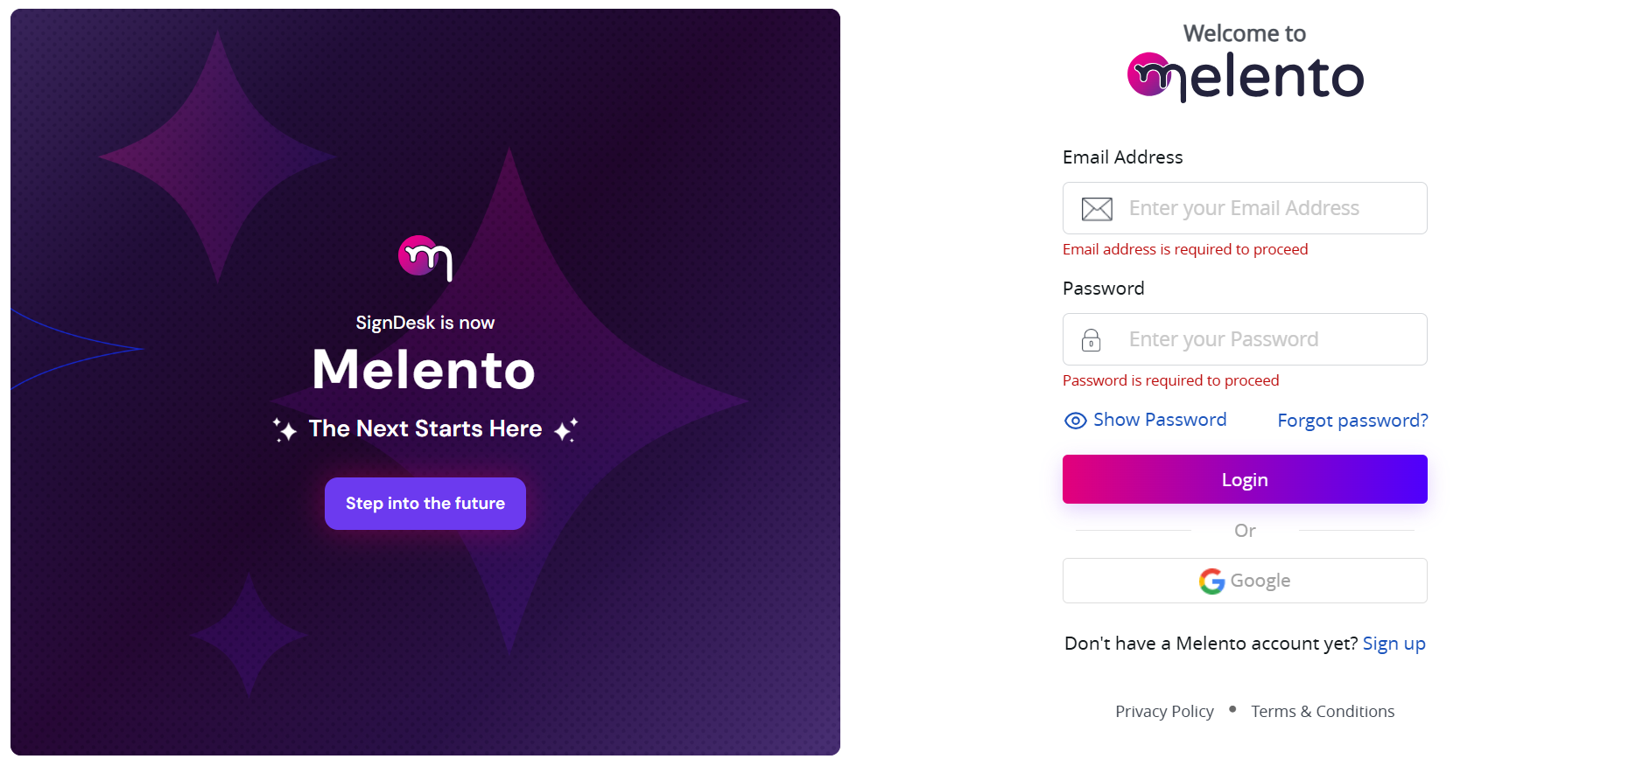

Different user groups log in to separate [dashboards](https://in.staging-signdesk.com/auth/#/login), each with role‑specific credentials:

* **Operations Dashboard**: Username and password required
* **Finance Dashboard**: Username and password required
* **Management Dashboard**: Username and password required
* **Client Dashboard**: Username and password required

*Contact* ***Vinay*** *for access and installation instructions.*

## **Upload Tool Access**

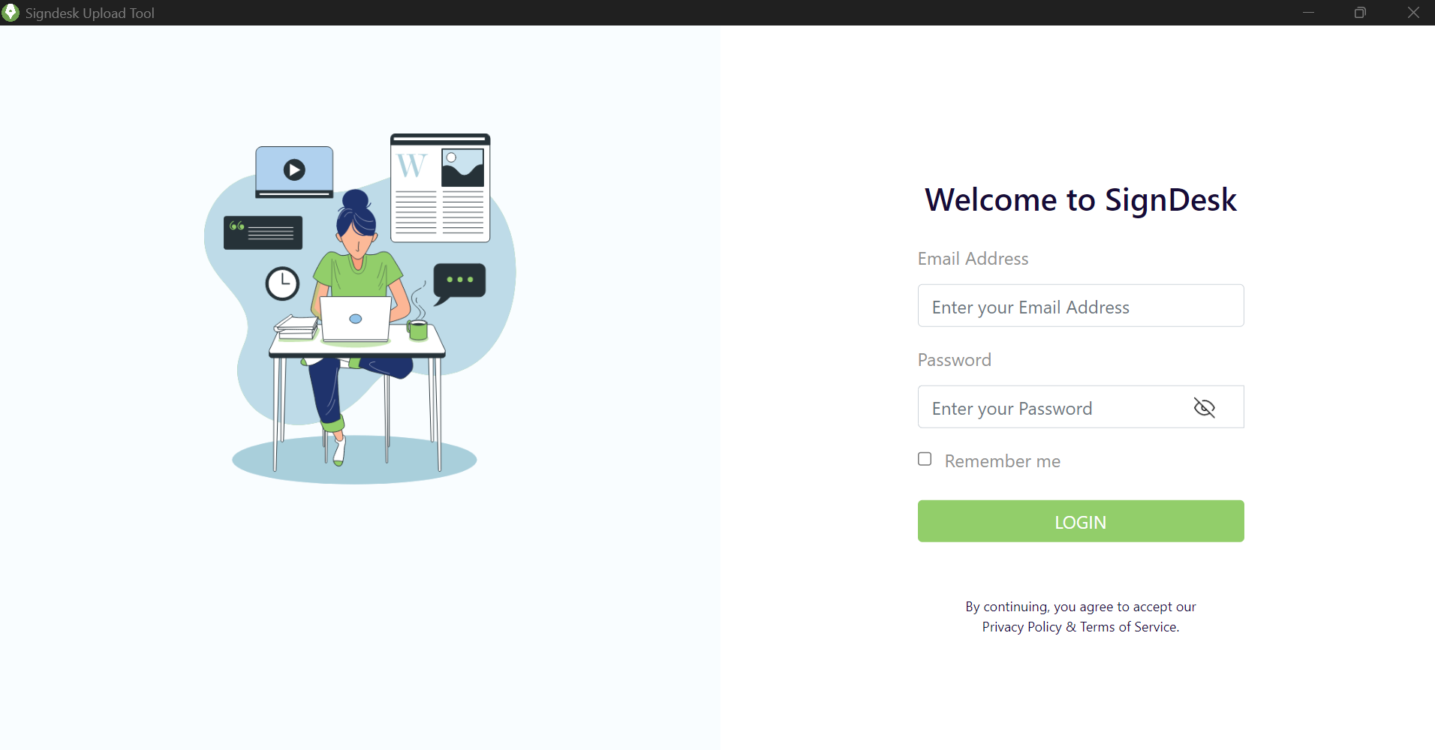

To [download](https://drive.google.com/file/d/1b6FPUW42ydfDzfaT6EC4l9o0zIzQZfYx/view?usp=sharing) and install the SignDesk Upload Tool (used for uploading procured stamp papers):

*Contact* ***Prakhar*** *for access and installation instructions.*

# **Accessing the Dispatch Tracker**

To access the Dispatch Tracker, follow these steps:

1. **Log in** to the [Dashboard](https://in.staging-signdesk.com/app/#/digital-stamp/dispatch-tracker) using your Operations credentials. *(Refer* *here**)*
2. On the **left-side menu**, locate and click on **Dispatch Tracker**.
3. The Dispatch Tracker module will open on the **right side of the screen**.

Once the tracker loads, you will see three primary tabs that categorize dispatch records:

* **Dispatched**: Records that have already been dispatched.

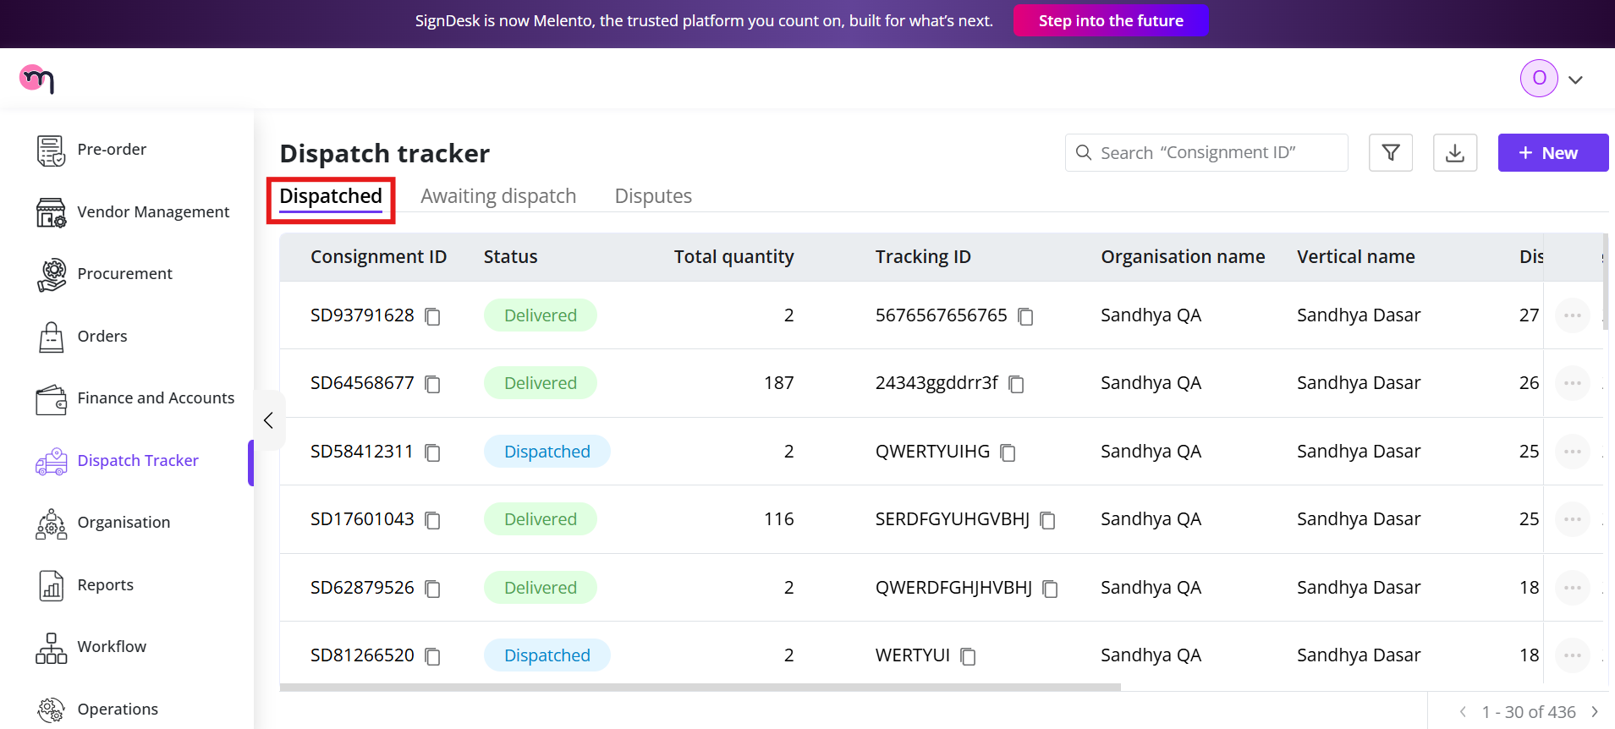

* **Awaiting Dispatch**: Records pending dispatch and require action.

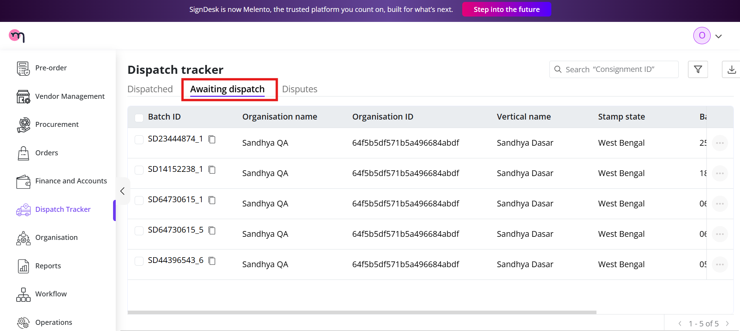

* **Disputes**: Records with discrepancies reported and requiring review or resolution.

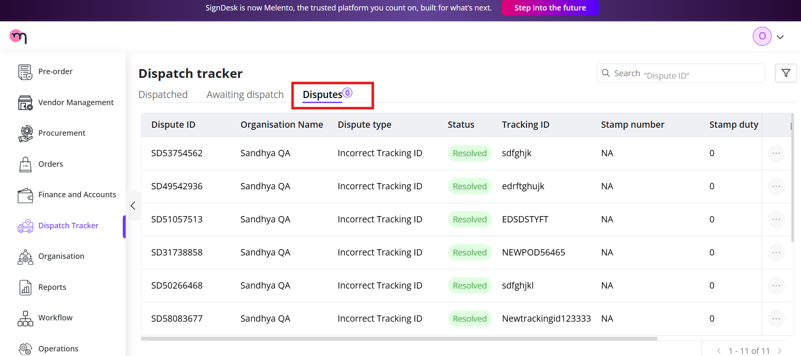

These sections help Operations teams quickly filter, monitor, and manage dispatch activity.

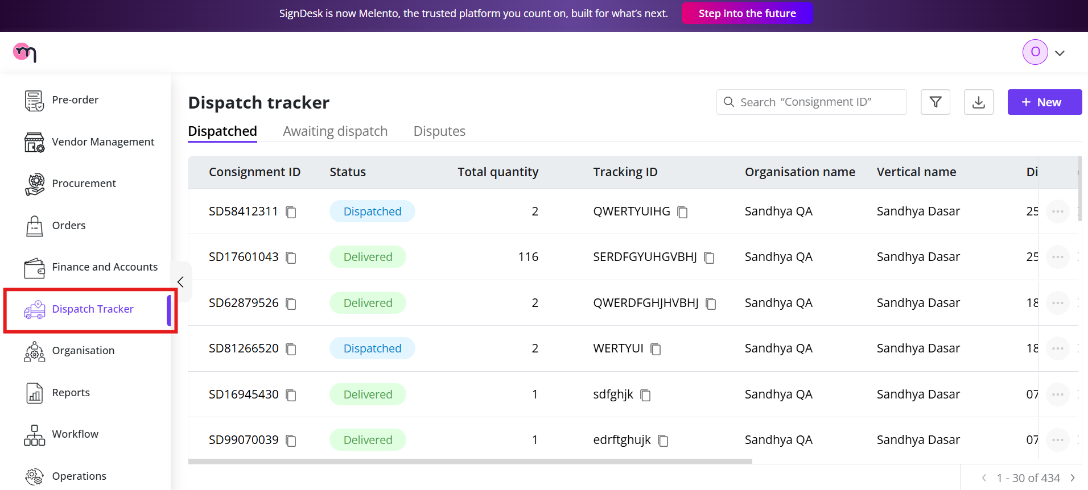

## **Dispatch Tracker Dashboard Components**

When the Dispatch Tracker loads, the right-side dashboard displays several tools and controls to help you manage and locate dispatch records efficiently.

### **Search Bar**

The search bar lets you locate specific dispatch entries.  
You can search using:

* **Consignment ID**

Simply enter the ID into the search field, and the matching record(s) will appear.

### **Filters**

The module includes a filter panel that allows you to narrow dispatch records by key criteria.

Available filters include:

* **Organisation ID**: Filter records for a specific organization.
* **Created On**: Select a date or date range for records uploaded on a particular day.
* **Status**: Filter records based on their current status:
  + **Dispatched**
  + **Delivered**
  + **Dispute Raised**

Users can apply one or multiple filters to refine the results.

### **Tabs**

The dashboard contains three tabs that categorize the records:

* **Dispatched**: All records sent through the courier.
* **Awaiting Dispatch**: Records uploaded but not yet dispatched.
* **Disputes**: Records of user-reported discrepancies.

Switching between these tabs helps Operations teams easily track the dispatch workflow.

### **Download Option**

A **Download** button is available for exporting dispatch data.

You can download:

* The complete dispatch list
* Filtered results (based on search and filters applied)

The downloaded file is typically in **CSV format**, allowing further review or reporting. The screenshot below illustrates the layout of the Tracker Dashboard.

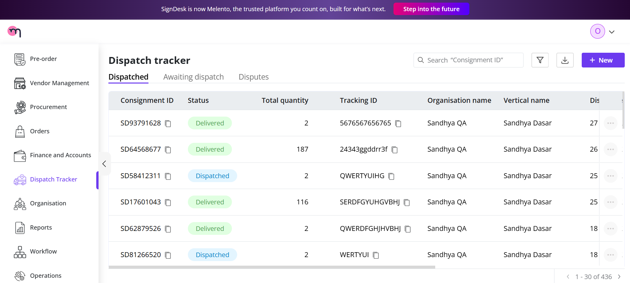

# **Adding a New Dispatch**

To create a new dispatch entry, follow the steps below:

1. Navigate to the **Dispatch Tracker** module.
2. In the **top-right corner** of the dashboard, click the **“+ New”** button.

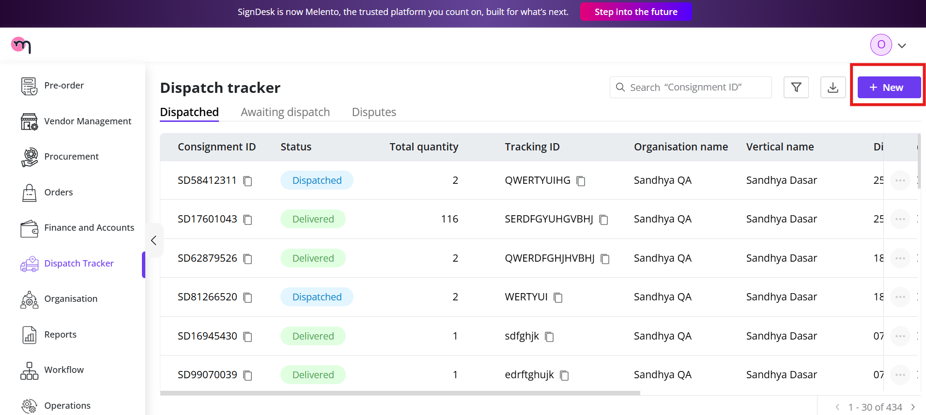

## **Selecting Stamp Type**

When adding a new dispatch, the form will first prompt you to choose the stamp type. Follow the steps below:

1. In the **Consignment Details** form, locate the **Select Stamp Type** dropdown.
2. Choose one of the following options:
   * **On the Fly**
   * **Traditional**
3. Based on your selection, the form will automatically update and display the relevant fields:
   * If you select **On the Fly**, you will be required to upload a **CSV file** containing stamp details.
   * If you select **Traditional**, you will be asked to enter the stamp information manually (as per system configuration).
4. Proceed to fill in the remaining fields after the stamp type selection.

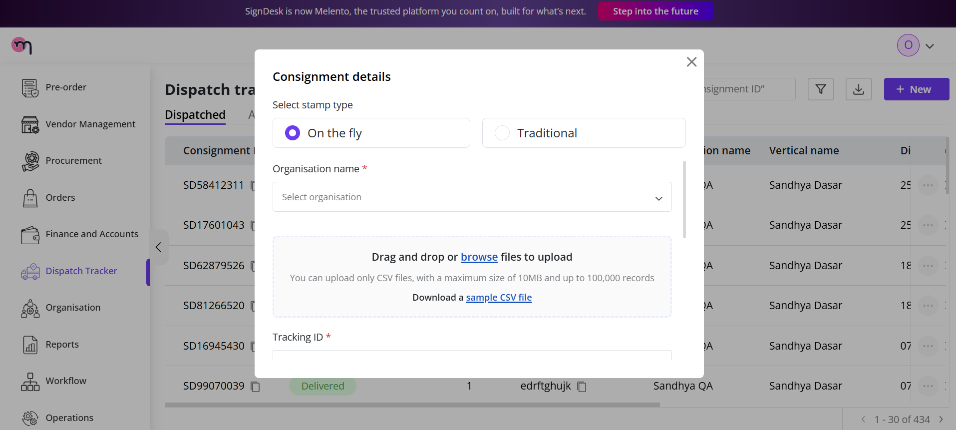

## **On the Fly: Consignment Details**

When you select **On the Fly** as the stamp type, the form will display specific fields required for uploading stamp information and completing the dispatch creation.

Follow the steps below:

1. **Select Stamp Type: On the Fly**Choose **On the Fly** from the stamp type dropdown.
2. **Organisation Name**Select the organisation for which the stamps are being dispatched.
3. **Upload File (CSV)**
   * The form will prompt you to upload a **CSV file** containing stamp details.
   * You can **drag and drop** the file or click **Browse** to upload it.
   * The CSV must include the predefined stamp data fields required by the system.
4. **Tracking ID**Enter the tracking number provided by the courier partner.
5. **Delivered Date**If the stamps have already been delivered, you can enter the delivery date here.
6. **Weight**Enter the total weight of the package/consignment.
7. **Courier Partner**Select the courier partner handling the dispatch (e.g., Blue Dart, DTDC, etc.).
8. **Delivery Address** Enter the complete delivery address where the consignment should be sent.
9. **Submit** After filling all required fields, click **Submit** to create the dispatch entry in the system.

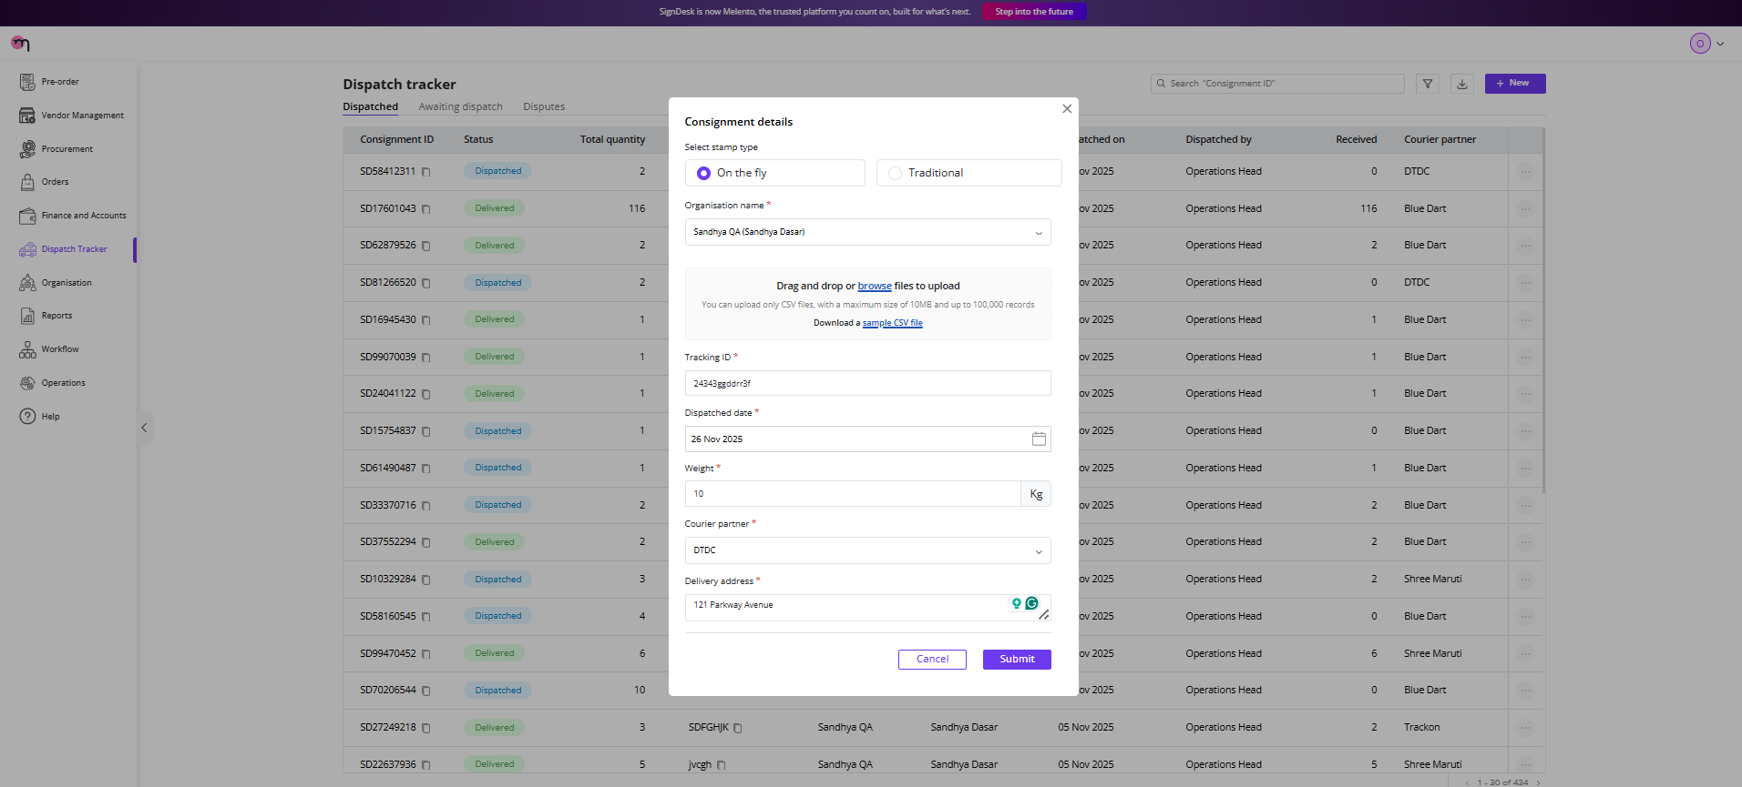

## **CSV File Requirements**

When selecting **On the Fly** as the stamp type, you must upload a CSV file containing the required stamp details. The CSV should include the following mandatory columns:

1. **Stamping Number** A unique identifier assigned to each stamp entry.
2. **Stamp State** The state for which the stamp paper is issued (e.g., Karnataka, Maharashtra).
3. **Stamp Amount** The monetary value or denomination of the stamp.

### **Avoid Redundancies**

Ensure that the CSV file:

* Does **not** contain duplicate or repeated stamping numbers
* Does **not** include redundant or invalid entries
* Has consistent and accurate data across all rows

Any redundancy or mismatch in the CSV may automatically trigger a **dispute** or cause the upload to be rejected by the system.

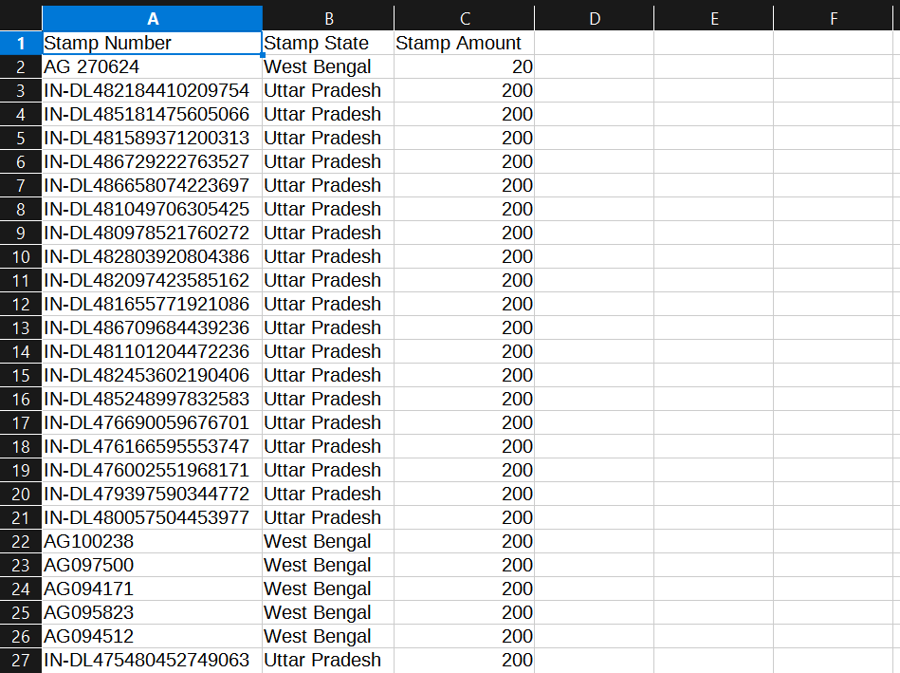

### **Upload Summary Details**

After completing the bulk upload using the CSV file, the dashboard will display a categorized summary of the results. These categories help you quickly identify which records were successfully processed and which require attention.

#### **1. Success Entries**

These are the records that were uploaded correctly and passed all validations.

* All mandatory fields were present
* No duplicates were detected
* Stamp details matched the required format  
  These entries are added to the dispatch list without any issues.

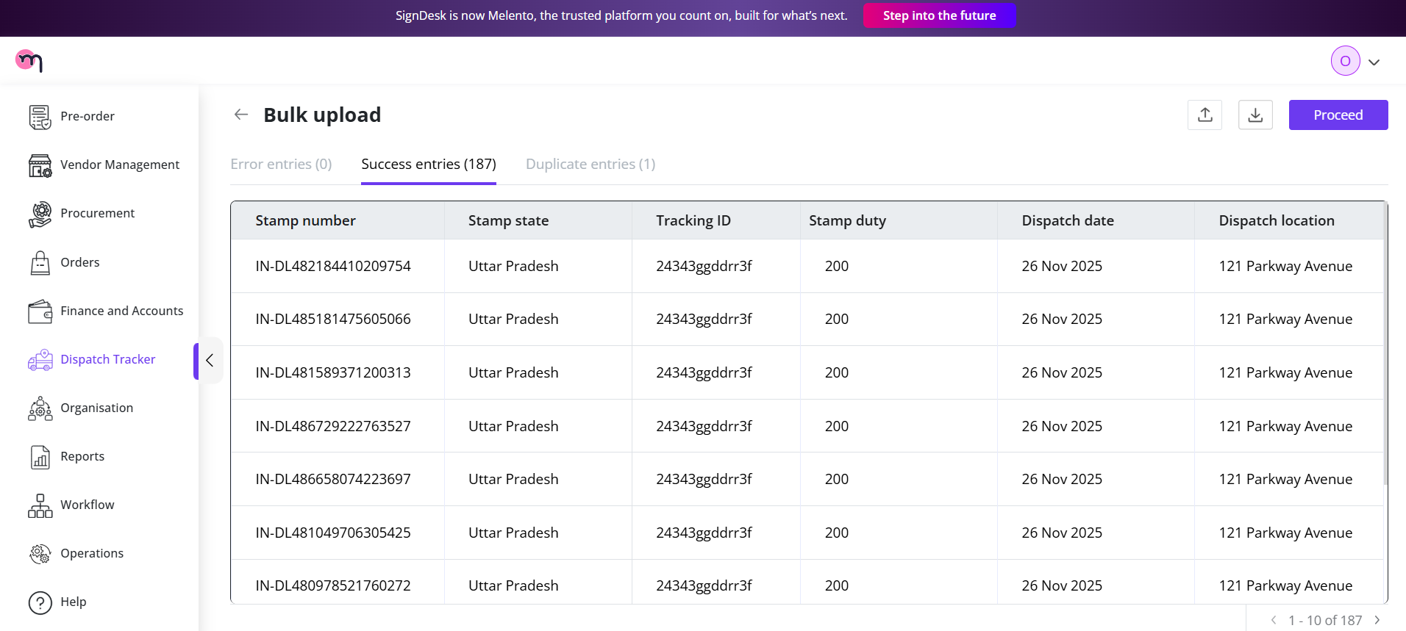

#### **2. Error Entries**

These entries contain issues that prevent the system from processing them.  
 Common reasons include:

* Missing mandatory fields (e.g., stamping number, state, amount)
* Incorrect or invalid data formats
* Empty rows or improperly structured CSV  
  These entries must be corrected and re-uploaded using an updated CSV file.

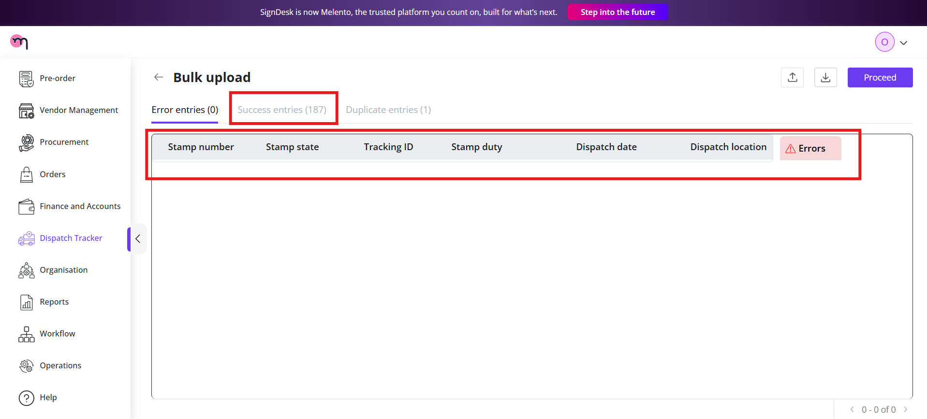

#### **3. Duplicate Entries**

These are records where the **Stamping Number** or other unique identifiers appear more than once in the uploaded CSV.

* The system flags and segregates them to avoid inconsistencies
* These entries are **not** added to the dispatch list
* You must remove or correct these duplicates before re-uploading

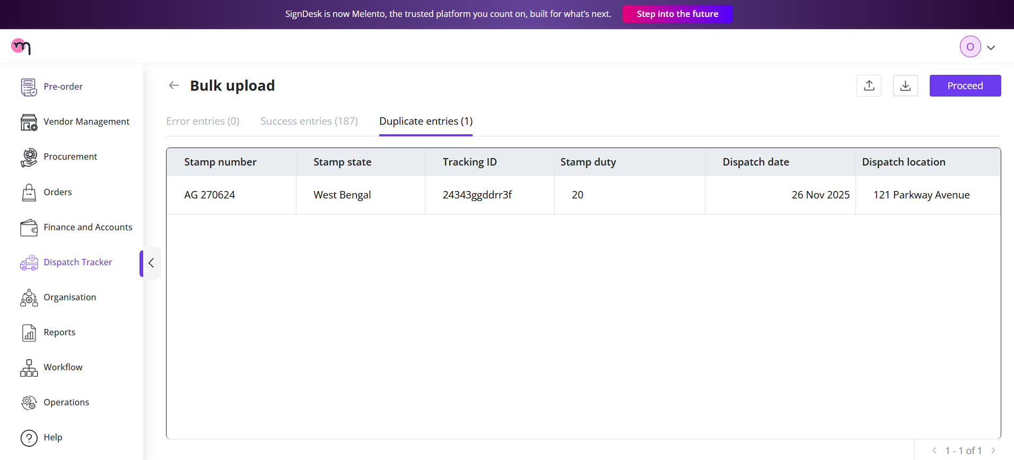

Upon successful upload, the system will display a confirmation message indicating that the file was uploaded successfully

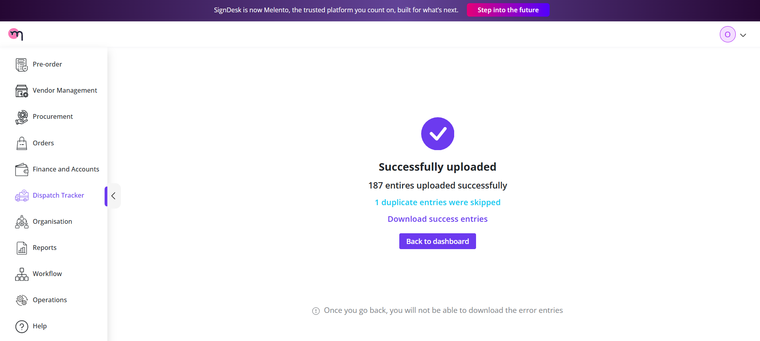

# **Viewing Uploaded Consignments on the Dashboard**

After a successful CSV upload, the dashboard will display the newly added consignment(s) with the following details:

* **Consignment ID**: A unique identifier for each consignment.
* **Status**: Current status of the dispatch (e.g., Awaiting Dispatch, Dispatched, Delivered, Dispute Raised).
* **Total Quantity**: Total number of stamps included in the consignment.
* **Organisation Name**: Name of the organisation associated with the consignment.
* **Vertical Name**: Business vertical or department linked to the consignment.
* **Dispatched On**: Date when the consignment was dispatched.
* **Dispatched By**: Name of the user who processed the dispatch.
* **Received**: Confirmation of receipt by the recipient (if available).
* **Courier Partner**: Name of the courier service handling the delivery.

**Note:** Newly added consignments will appear **at the top** of the dashboard for quick access and visibility.

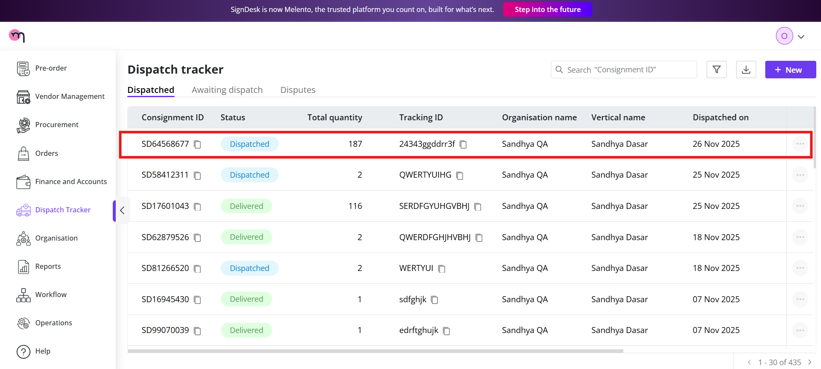

Upon clicking on the specific consignment ID, you can view more of its details as shown below.

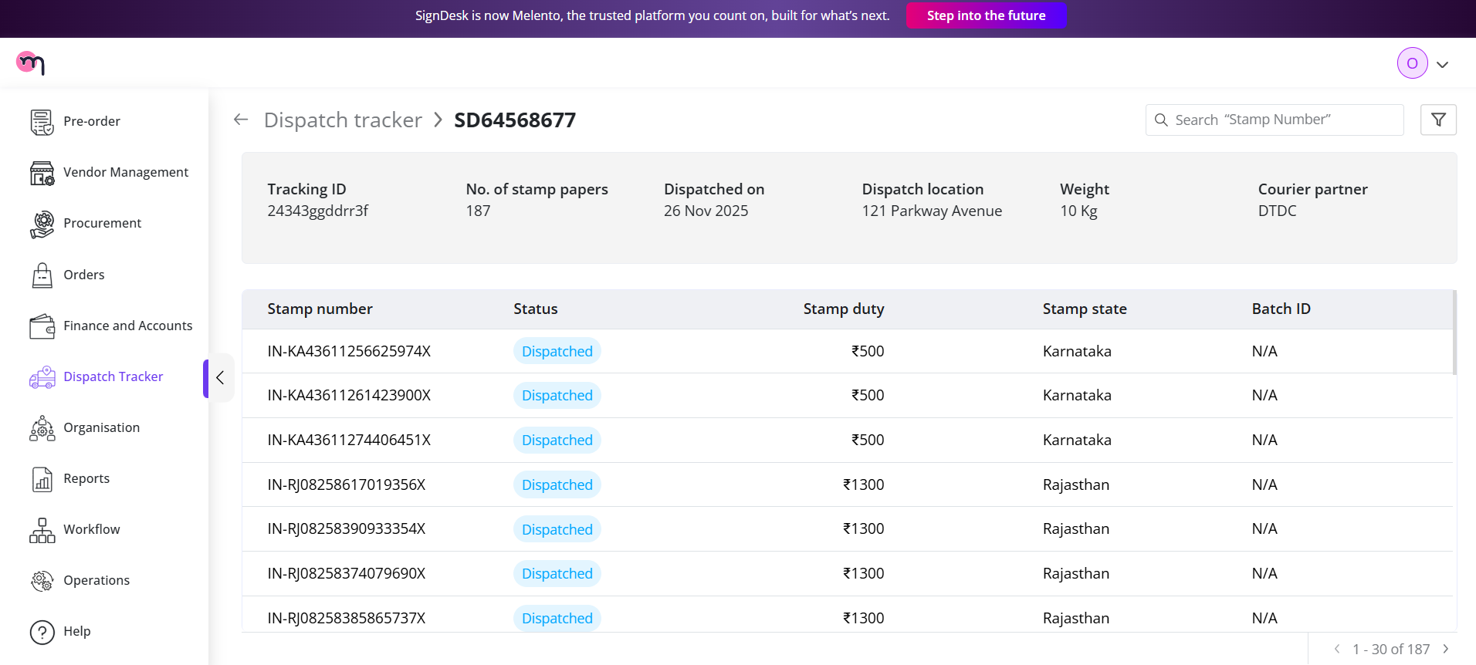

# **Consignment Actions**

For each consignment displayed on the dashboard, the **three horizontal dots** on the top-right corner of the consignment row provide additional actions:

1. **View Batch**
   * Opens the full batch of stamps included in the consignment.
   * Allows you to verify individual stamp details and their status.
2. **Download CSV**
   * Exports the consignment details as a CSV file.
   * Useful for offline review, audits, or reporting.
3. **Mark as Delivered**
   * Updates the consignment status to **Delivered**.
   * Confirms that the package has been received by the recipient.
   * This action may trigger notifications and update relevant records in the dashboard.

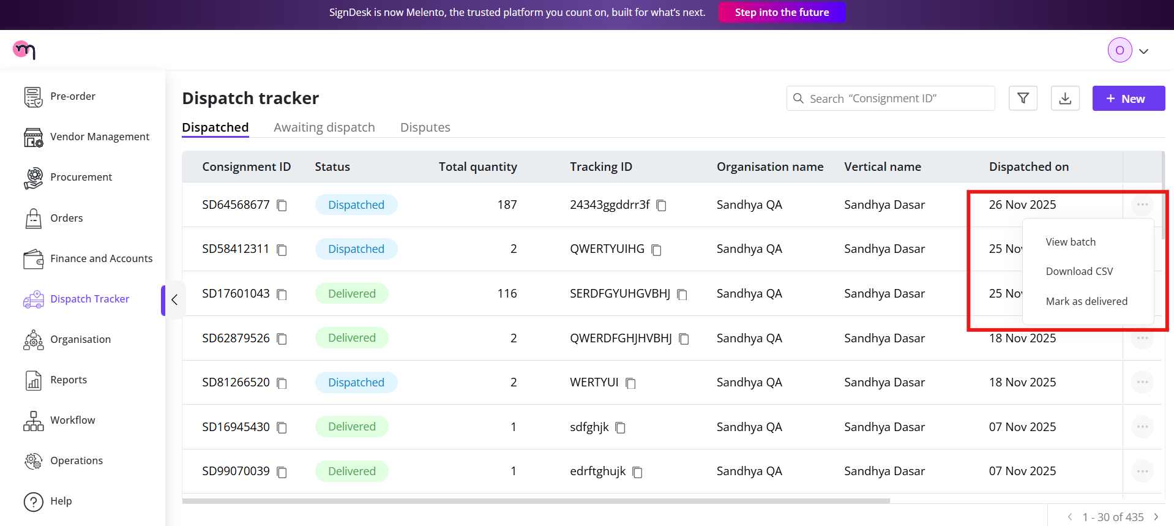

### **Marking a Consignment as Delivered**

Once a consignment’s status is **Dispatched**, you can mark it as **Delivered** using the actions menu.

**Steps to mark a consignment as delivered:**

1. Click the **three horizontal dots** on the top-right corner of the consignment row.
2. Select **Mark as Delivered**.
3. A **Mark as Delivered form** will appear with the following fields:
   * **Delivered Date**: Enter the date on which the consignment was received.
   * **Upload Receipt**: Upload an acknowledgment or payment receipt as proof of delivery. The Operations team is responsible for uploading this document.
4. Click **Submit** after filling in the required fields.

**Outcome**

* Upon submission, the consignment status will automatically update from **Dispatched** to **Delivered** on the dashboard.
* The delivered date and uploaded receipt will be reflected in the consignment details for record-keeping and auditing purposes.

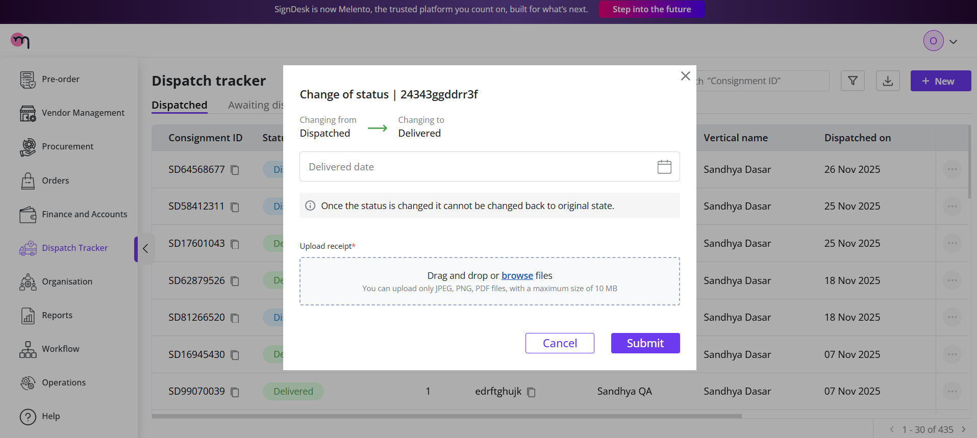

Upload an acknowledgement (Payment receipt) and then click on the submit button.

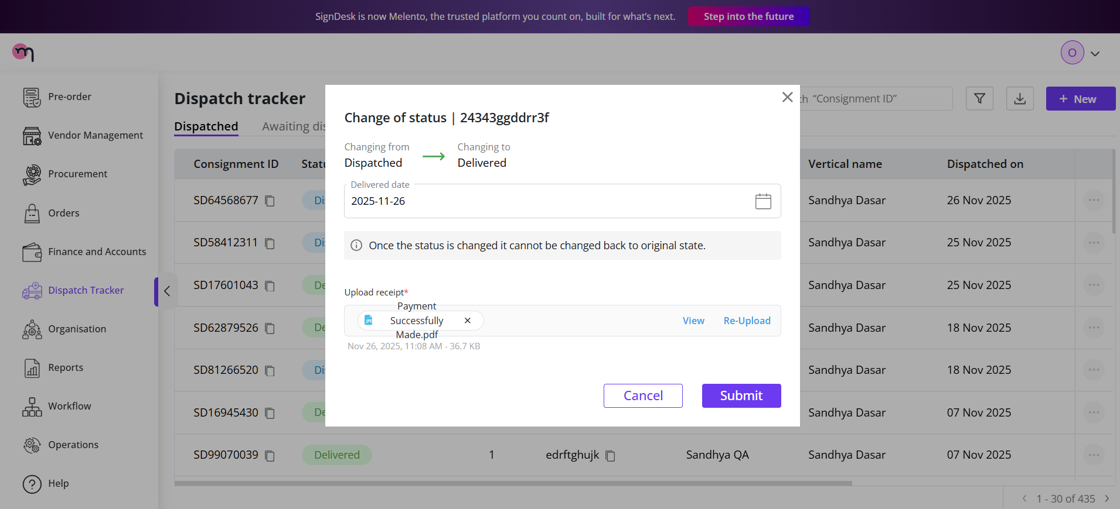

Upon doing so, the status will be changed from Dispatched to Delivered as seen below.

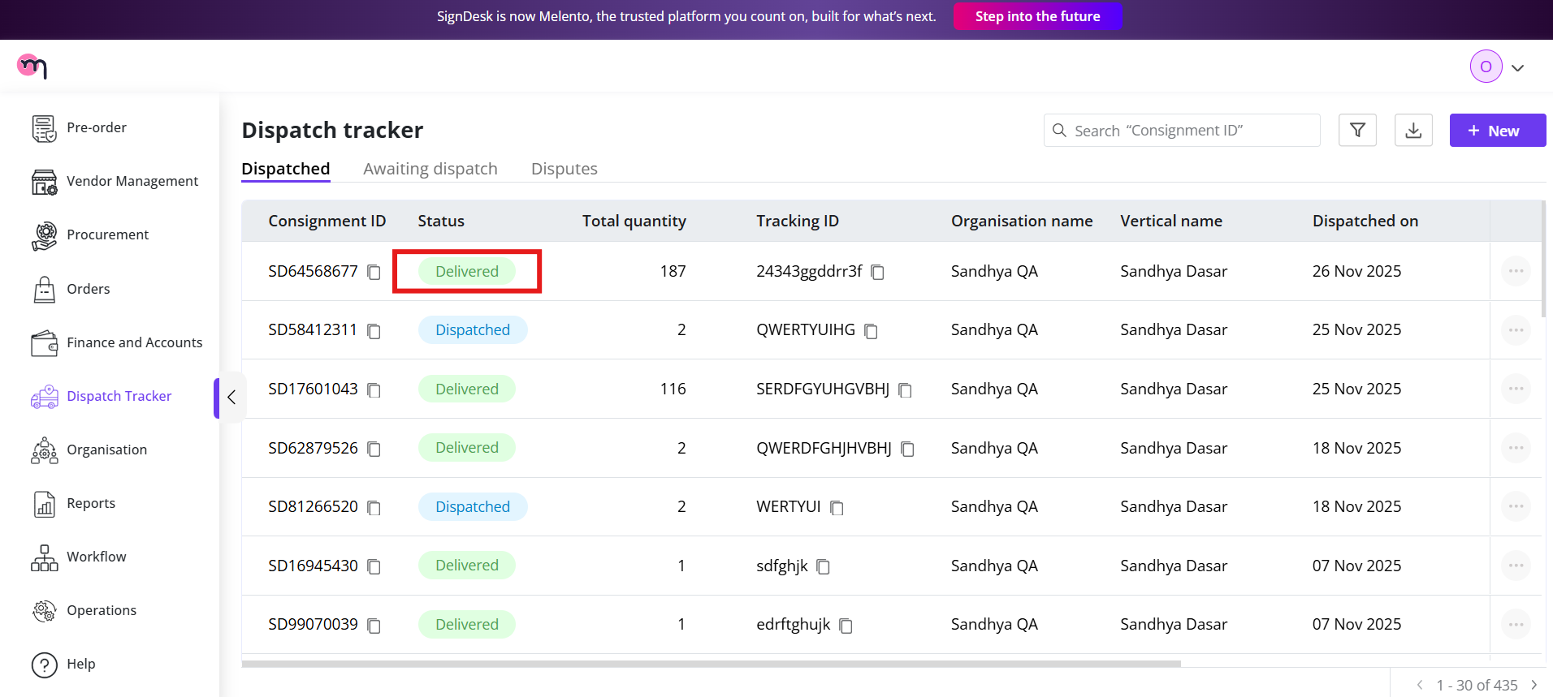

### 

### **Viewing Consignment Details**

For more information about a specific consignment, you can click on the **Consignment Details**. This opens a detailed view of the dispatch, providing all relevant information in a single place.

**Key points in the detailed view:**

* Displays all consignment fields, including Consignment ID, Status, Total Quantity, Organisation Name, Vertical Name, Dispatched On, Dispatched By, Received status, and Courier Partner.
* Shows any uploaded receipts or CSV files associated with the consignment.
* Allows you to verify batch-level information for auditing and tracking.

**Note:** For **On the Fly** consignments, the **Batch ID** will show as **N/A**, since individual stamps are processed directly from the uploaded CSV rather than grouped into a batch.

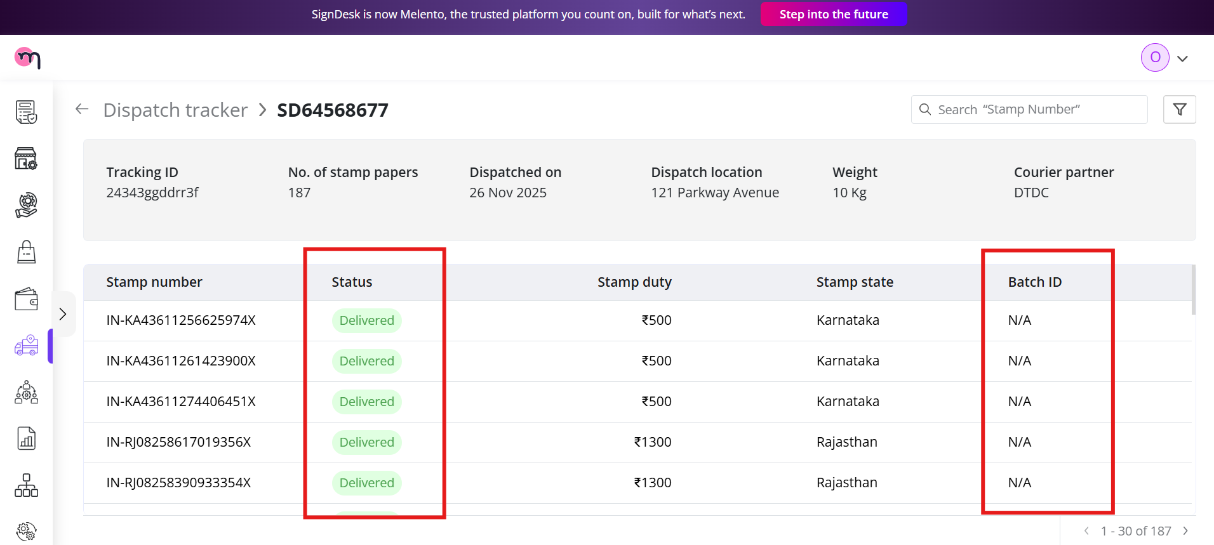

# **Traditional**

## **Creating a Pre-Order**

For **Traditional** stamps, a pre-order must be created to assist the SignDesk procurement team in fulfilling the request. The pre-order form serves as a projection of your stamp requirements and ensures proper planning and allocation.

### **Steps to Place a Pre-Order**

1. Navigate to the **Dispatch Tracker** and click **+ New**.
2. Select **Traditional** as the **Stamp Type**.
3. Fill in the pre-order form with the following details:
   * **Organisation**: Select the organisation placing the pre-order.
   * **Party Details**: Provide information for both parties involved in the stamp transaction:
     + **First Party**: Name and relevant details.
     + **Second Party**: Name and relevant details.
   * **Stamp State and Location**: Specify the state and location where the stamp paper will be issued.
   * **Agree to Terms and Conditions**: Check the box to confirm acceptance of the terms.
4. Click **Place a Pre-Order** to submit the request.

**Outcome:**

* The pre-order is sent to the SignDesk procurement team for processing.
* This pre-order acts as a projection of the required stamps and does not immediately create a dispatch entry.
* The procurement team will update the dashboard once the stamps are procured and ready for dispatch.

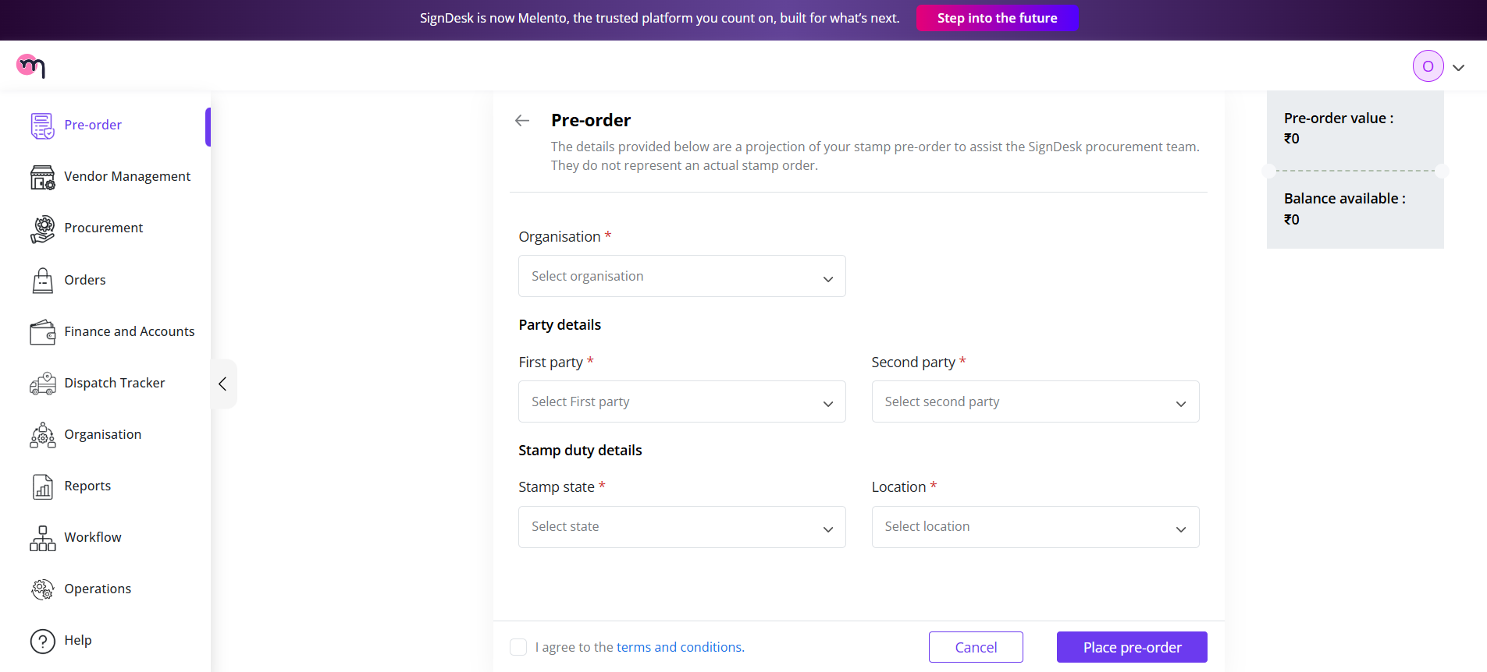

In the stamp type. Make sure to choose **Traditional**

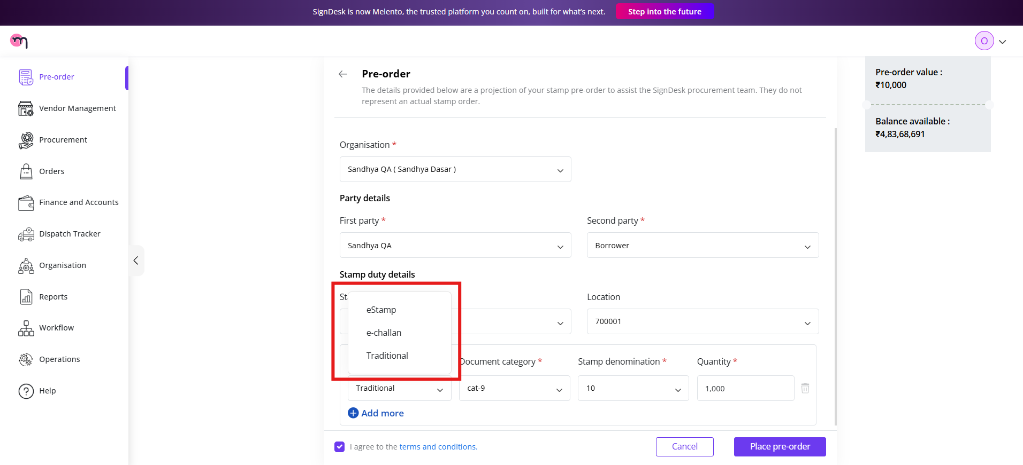

## **Viewing Pre-Order Details**

Once a Traditional stamp pre-order is created, you can access its details in the **Pre-Order Dashboard**, located on the **left side of the navigation pane**.

**Key points:**

* As it is a new order, it will appear **at the top** of the dashboard for easy access.
* The dashboard displays the following details for each pre-order:
  + **Pre-Order ID**: Unique identifier for the pre-order.
  + **Status**: Current status of the pre-order. Newly created pre-orders will have the status **Requested**.
  + **Created On**: Date when the pre-order was placed.
  + **Organisation**: Organisation placing the pre-order.
  + **Vertical Name**: Associated business vertical or department.
  + **State**: Stamp state and location.
  + **Available**: Number of stamps available in inventory for this pre-order.
  + **Consumed**: Number of stamps already allocated or used.
  + **Unassigned**: Number of stamps yet to be allocated.

This dashboard allows Operations and users to track pre-orders, monitor inventory, and check the status of stamp allocations efficiently.

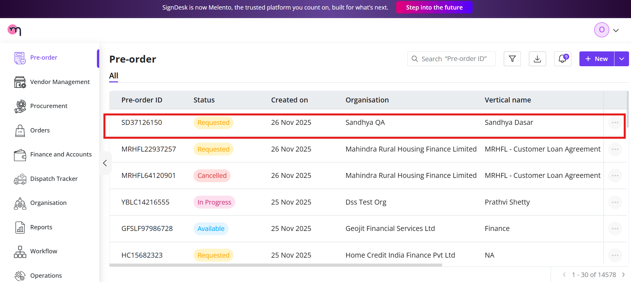

## **Finance Team Approval**

After a Traditional stamp pre-order is created, the request is routed to the **Finance Team** for review. The Finance Team can log in to the dashboard to **approve or reject** the pre-order based on internal checks and funding availability.

**Steps for Finance Team:**

1. **Log in** to the SignDesk Dashboard using Finance Team credentials.
2. Navigate to the **Pre-Order Dashboard** from the left-side navigation pane.
3. Locate the new pre-order request (status will be **Requested**) at the top of the dashboard.
4. Open the pre-order details to review the submitted information, including:
   * Organisation and Vertical Name
   * Party details
   * Stamp state and location
   * Quantity requested

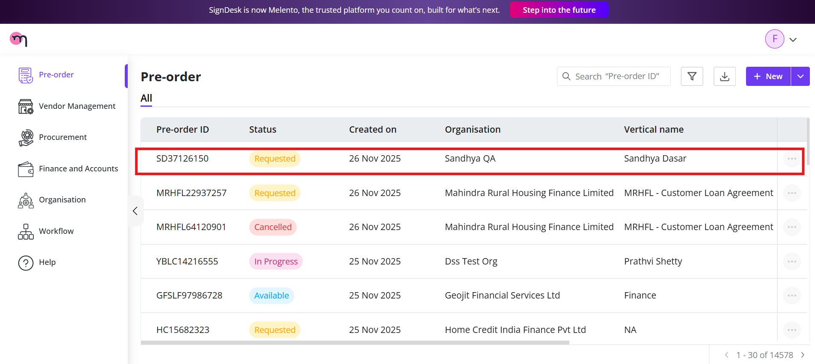

1. **Approve or Reject** the pre-order:
   * **Approve**: Confirms the request and forwards it to the Operations/Procurement team for processing.
   * **Reject**: Declines the request with optional comments for the requester.

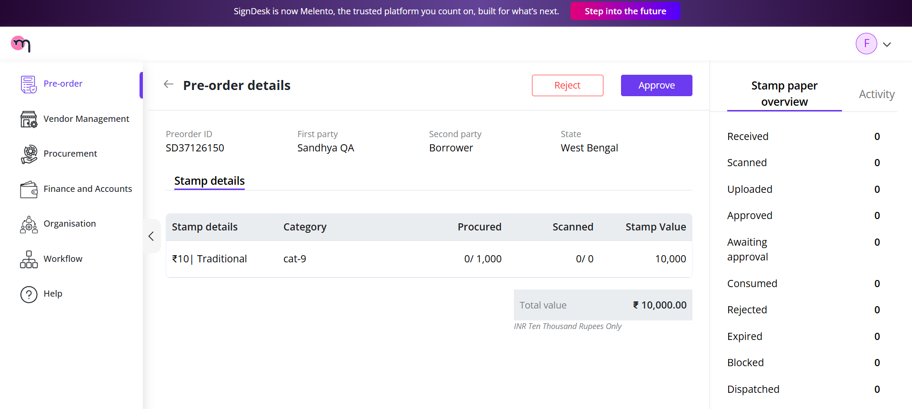

**Outcome:**

* Approved pre-orders move forward to the Operations/Procurement workflow for dispatch preparation.
* Rejected pre-orders remain in the dashboard with a **Rejected** status and can be reviewed or resubmitted if required.

## **Management Team Approval**

After the Finance Team approves a Traditional stamp pre-order, the request is routed to the **Management Team** for final review. The Management Team also logs in to the dashboard to **approve or disapprove** the pre-order.

**Steps for the Management Team:**

1. **Log in** to the SignDesk Dashboard using Management Team credentials.
2. Navigate to the **Pre-Order Dashboard** from the left-side navigation pane.
3. Locate the pre-order request (status will reflect **Finance Approved**) at the top of the dashboard.
4. Open the pre-order details to review the information, including:
   * Organisation and Vertical Name
   * Party details
   * Stamp state and location
   * Quantity requested

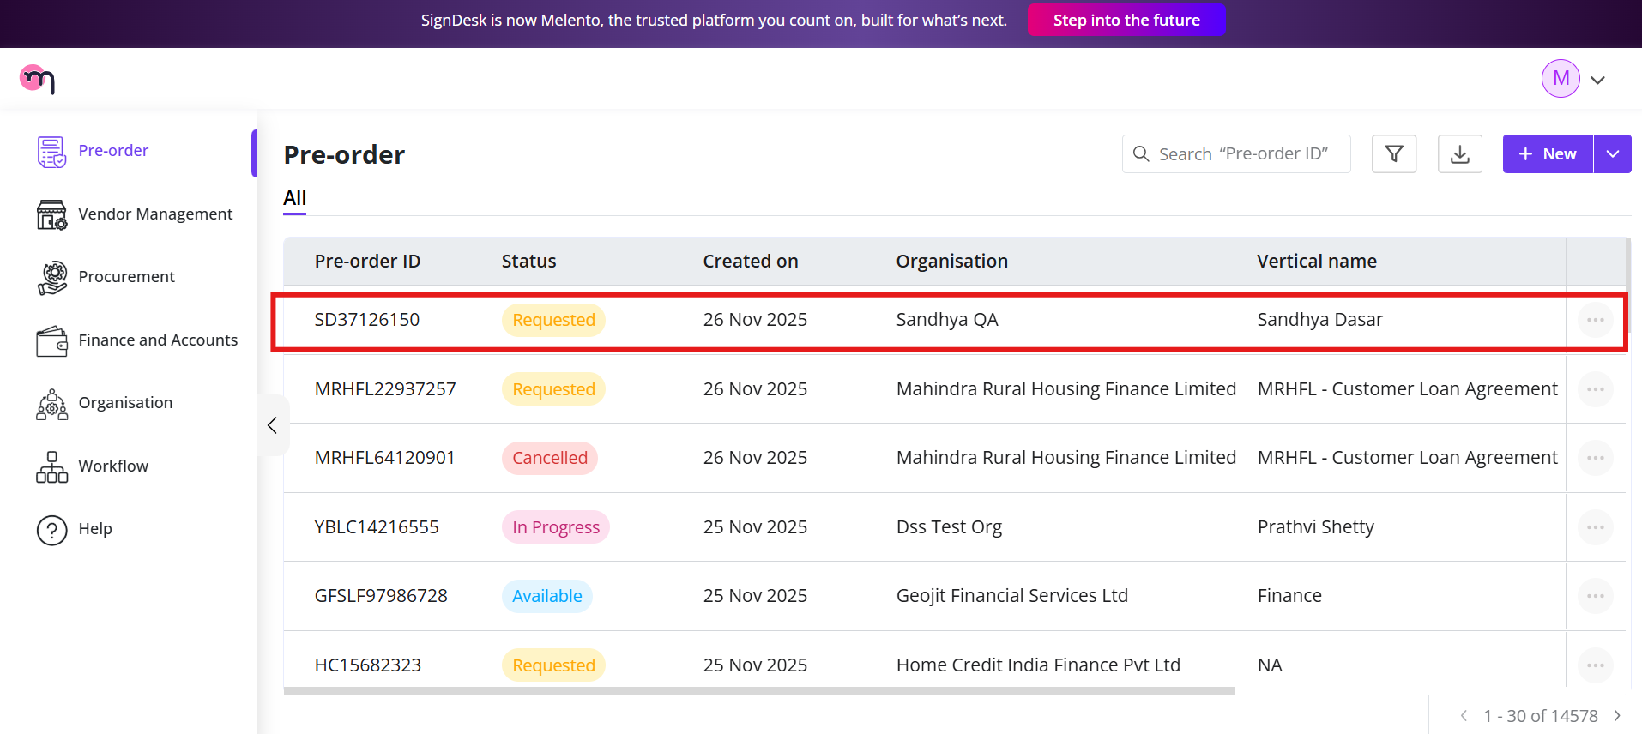

1. **Approve or Disapprove** the pre-order:
   * **Approve**: Confirms the pre-order and sends it back to the Operations/Procurement team for processing and eventual dispatch.
   * **Disapprove**: Declines the pre-order with optional comments for the requester.

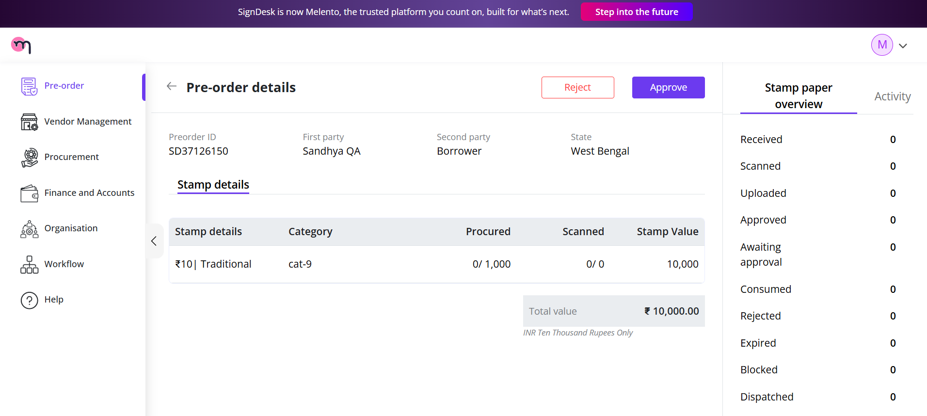

**Outcome:**

* Approved pre-orders proceed to the Operations workflow for dispatch creation.
* Disapproved pre-orders remain in the dashboard with a **Disapproved** status and can be reviewed or revised as needed.

## **Operations**

### **Assigning a Vendor**

Once the Management Team approves a Traditional stamp pre-order, it returns to the **Operations Dashboard** for vendor assignment. Operations can either **assign a vendor** to fulfill the order or **reject** the pre-order if required.

**Steps to Assign a Vendor:**

1. **Log in** to the SignDesk Dashboard using Operations credentials.
2. Navigate to the **Pre-Order Dashboard**.
3. Locate the approved pre-order (status will reflect **Management Approved**) at the top of the dashboard.
4. Click on the pre-order to open the **Assign Vendor** option.

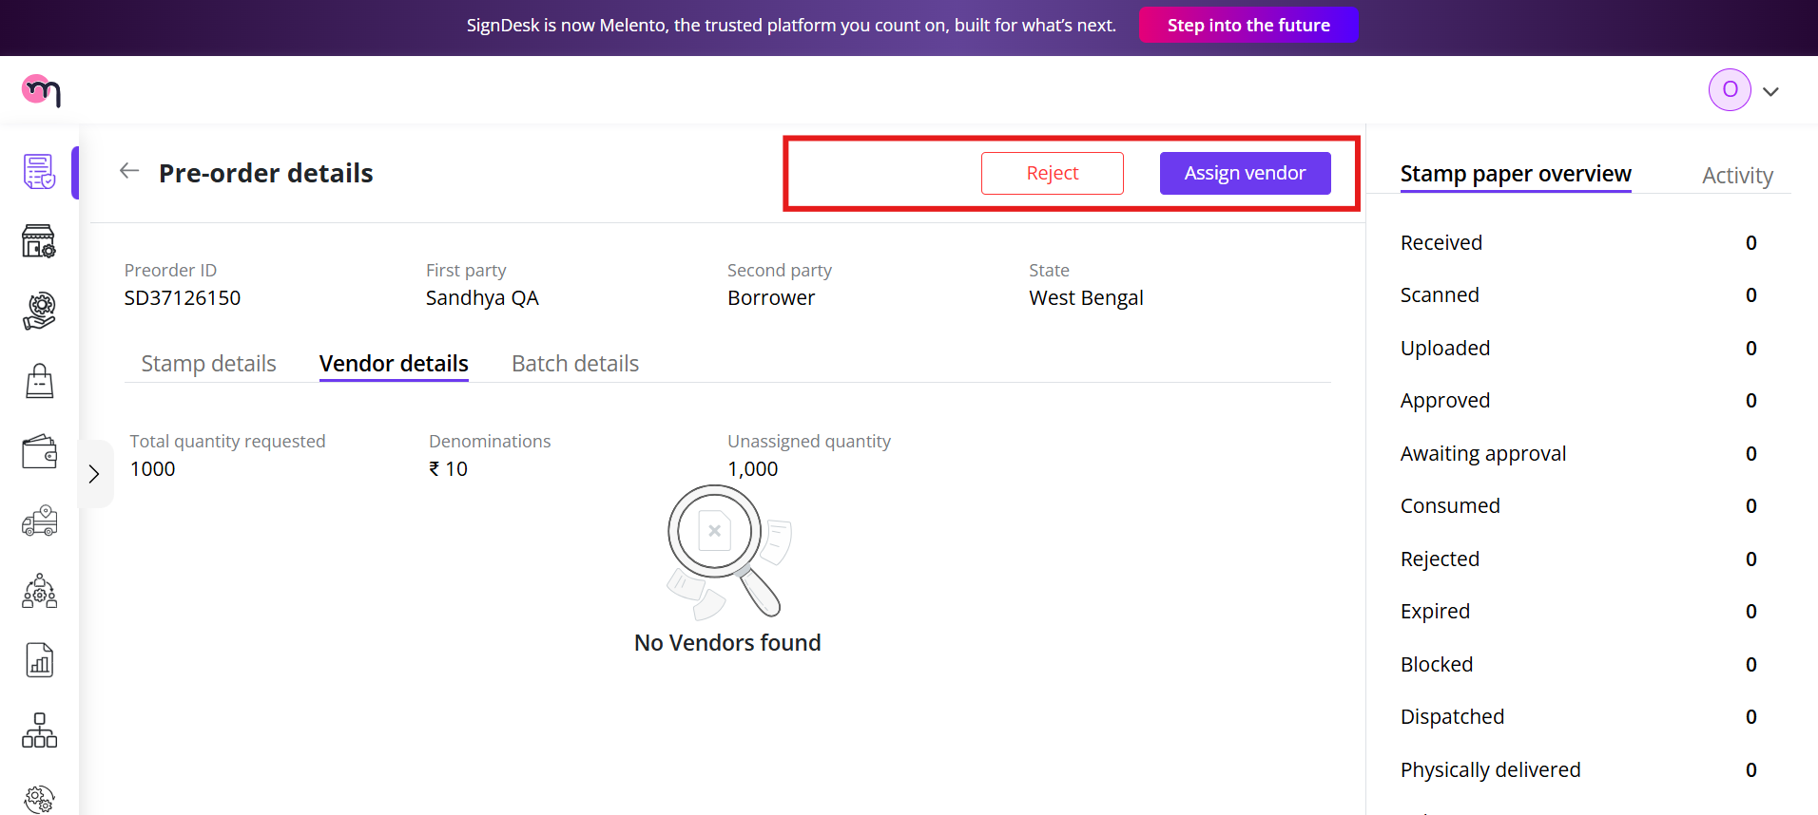

1. Review the pre-order details, which include:
   * **Pre-Order ID**
   * **Created By**: Name of the user who placed the pre-order
   * **Created On**: Date of pre-order creation
   * **Organisation**: Organisation placing the order
   * **State**: Stamp state and location
   * **Stamp Duty**: Stamp amount/denomination
   * **Quantity**: Number of stamps requested
   * Any other relevant details required for vendor assignment

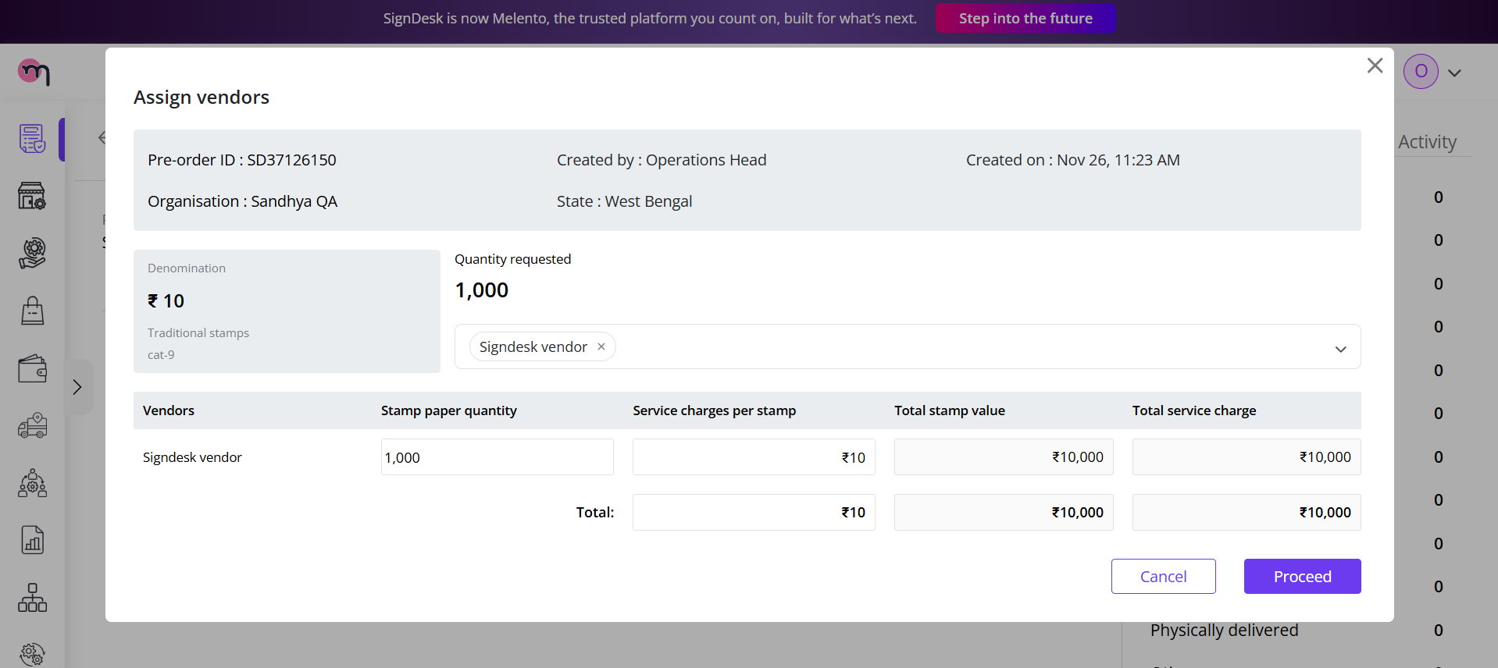

1. **Assign Vendor**: Select a vendor from the available list to fulfill the pre-order.
2. **Reject**: If necessary, the Operations team can reject the pre-order with optional comments.

**Outcome:**

* Upon assignment, the pre-order is linked to a vendor and prepared for dispatch creation.
* The status on the dashboard updates to reflect vendor assignment.

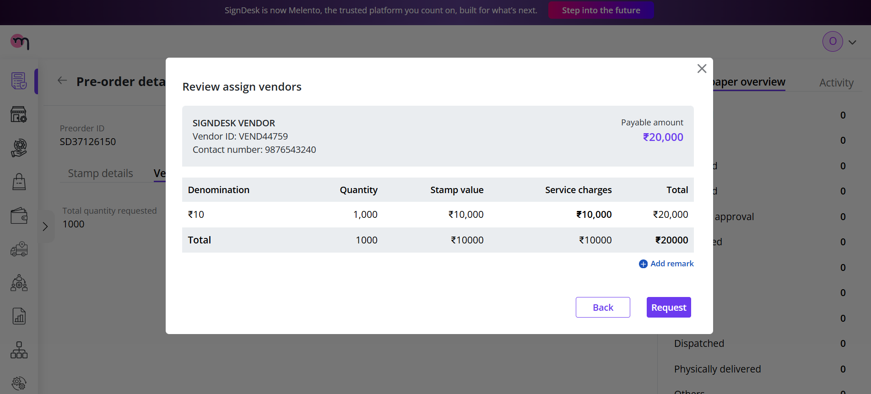

The activity logs on the right side of the dashboard show the details of the placement and the corresponding details

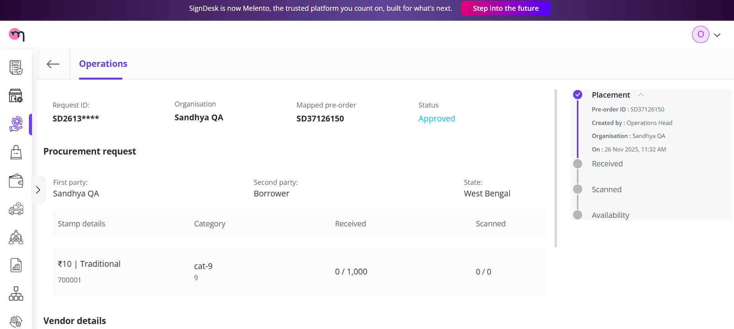

The vendor details can also be updated; here, we can change the procured stamp papers according to the requirement.

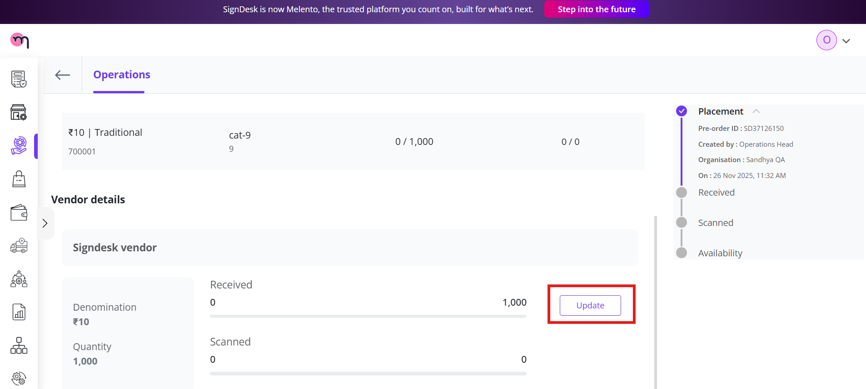

## **Vendor**

### **Updating Procured Stamps**

The assigned vendor can update the status of the pre-order as stamps are procured and received. This ensures accurate tracking and proper batch allocation.

**Steps to Update Procured Stamps:**

1. Navigate to the **Vendor Details** section of the pre-order in the Operations Dashboard.
2. Click the **Update** button next to the quantity field.
3. A **Procurement Form** will open, where the vendor can enter:
   * **Date of Procurement**: The date when the stamps were procured.
   * **Confirmed Quantity**: The number of stamps actually procured.

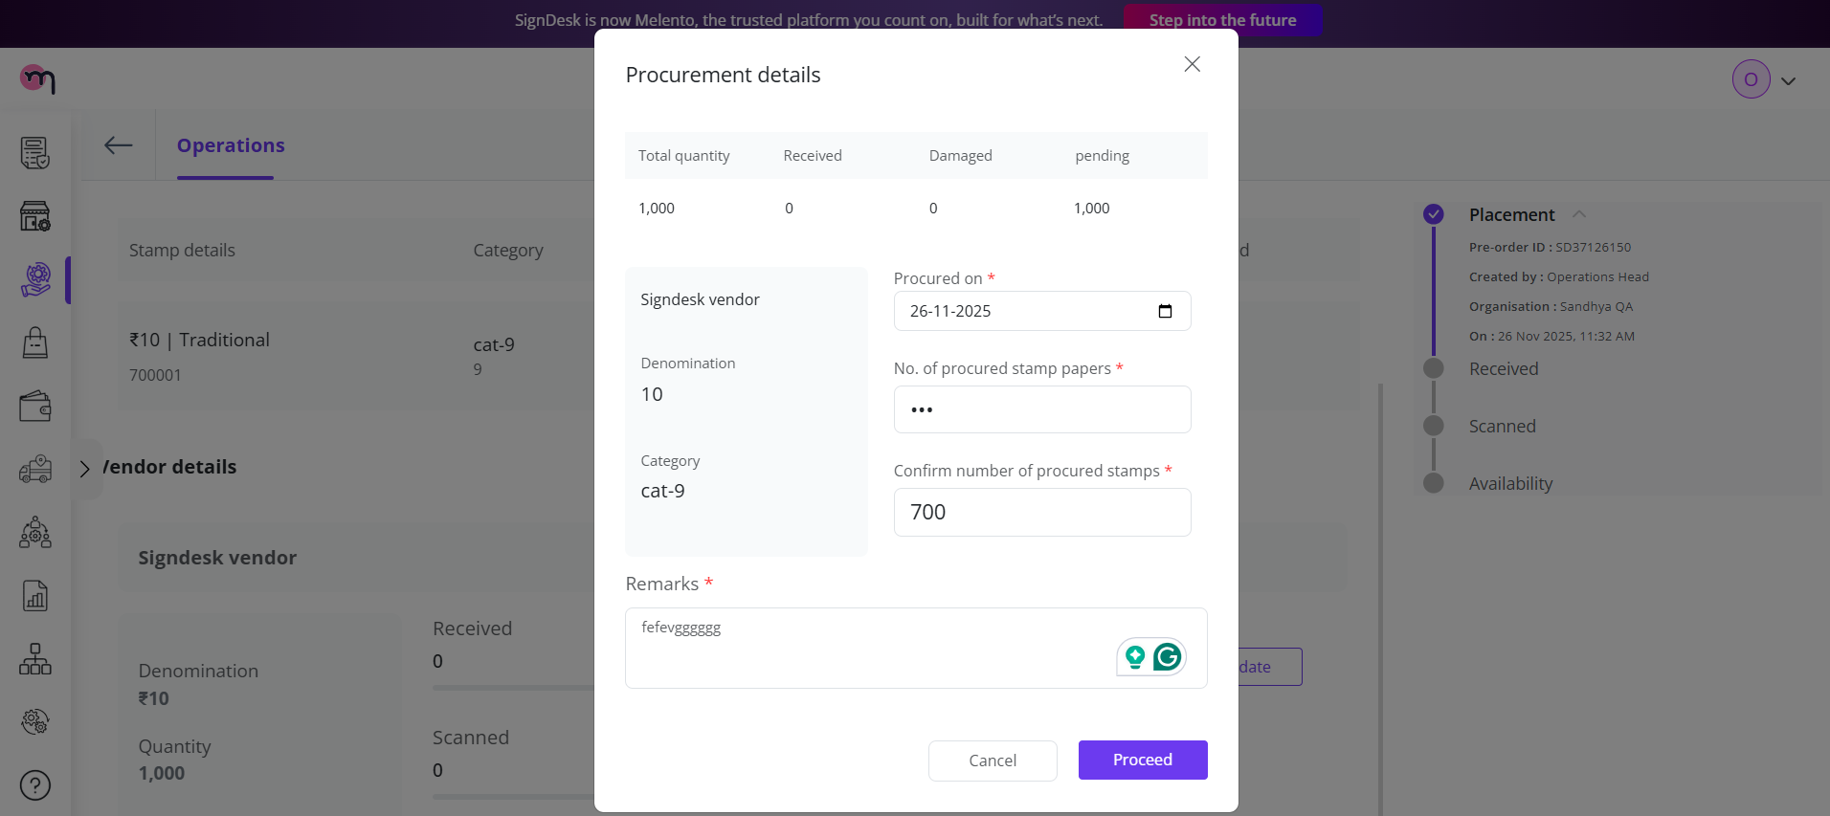

1. Click **Submit** to save the update.

**Outcome and Batch Creation:**

* The **Activity Tab** will reflect the updated quantity. For example, if the pre-order was for **1000 stamps** and the vendor confirms **700 stamps received**, the activity log will show the breakdown.

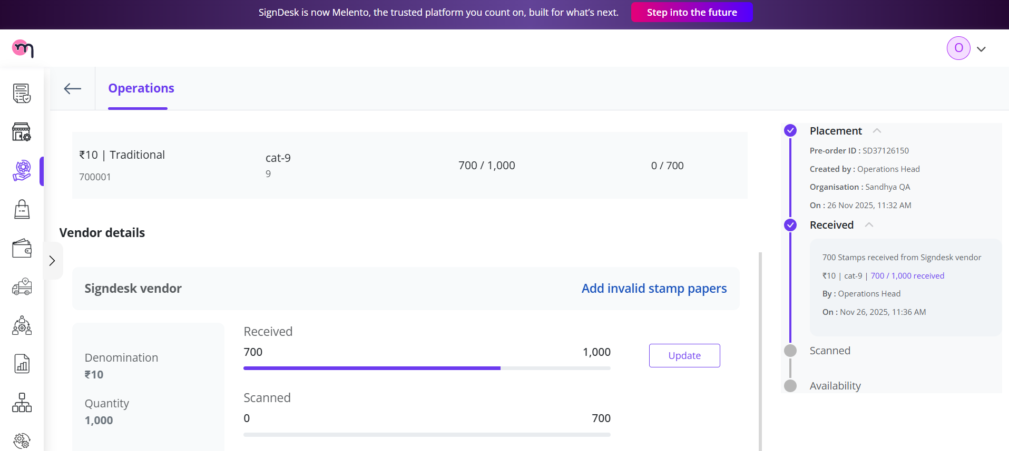

* Since the system has a **per-batch limit** (e.g., 500 stamps), the received stamps will be split into multiple batches:
  + **Batch 1:** 500 stamps
  + **Batch 2:** 200 stamps

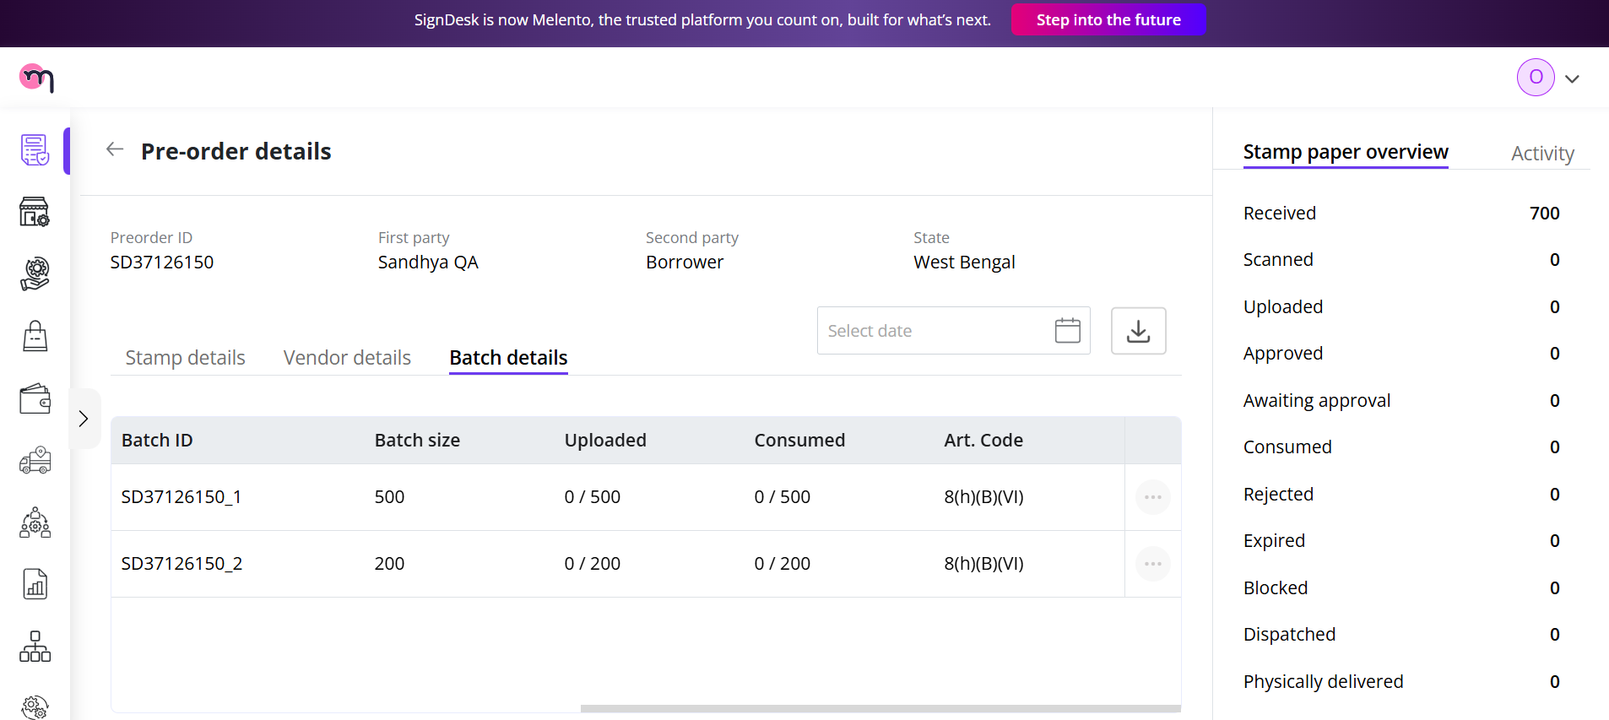

This batching ensures traceability and easier tracking of stamp allocations throughout the dispatch workflow.

### **Creating Additional Batches via Update**

If additional stamps are procured after the initial batch, vendors can create new batches using the **Update** functionality.

**Steps to create a new batch:**

1. Navigate to the **Vendor Details** section for the pre-order in the Operations Dashboard.
2. Click the **Update** button next to the quantity field.
3. In the **Procurement Form**, enter:
   * **Date of Procurement**: The date when these additional stamps were procured.
   * **Confirmed Quantity**: The number of stamps procured in this instance.
     + *Example:* Enter **2** if two stamp papers have been procured.

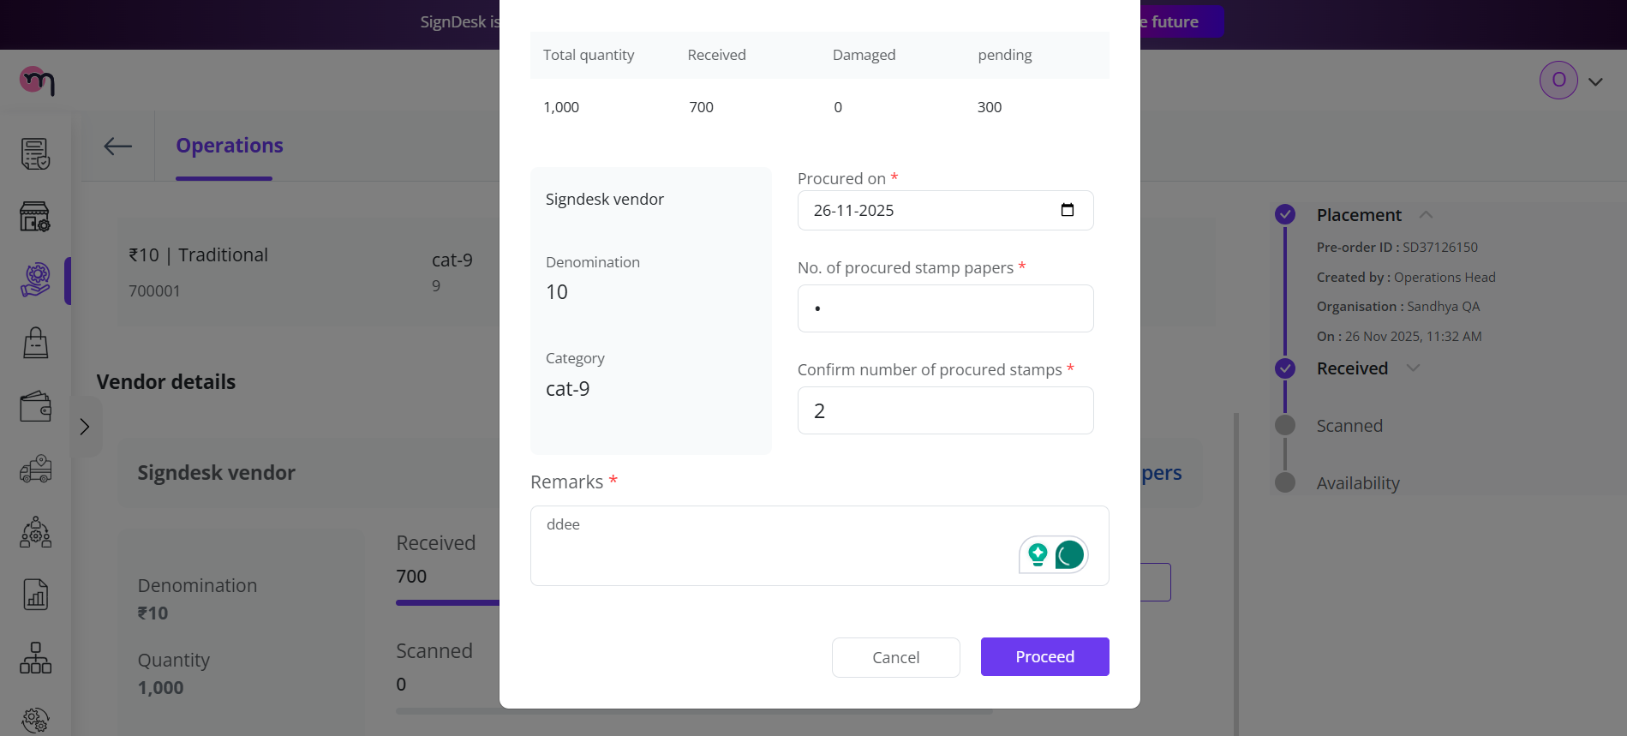

1. Click **Submit** to save the update.

**Outcome:**

* A new batch will be created automatically for the newly procured stamps.
* The **count entered** in the form represents the number of stamp papers to be uploaded for that batch.
  + In the example above, entering **2** creates a batch of 2 stamp papers.
* All batches are tracked separately for proper allocation, dispatch, and record-keeping.

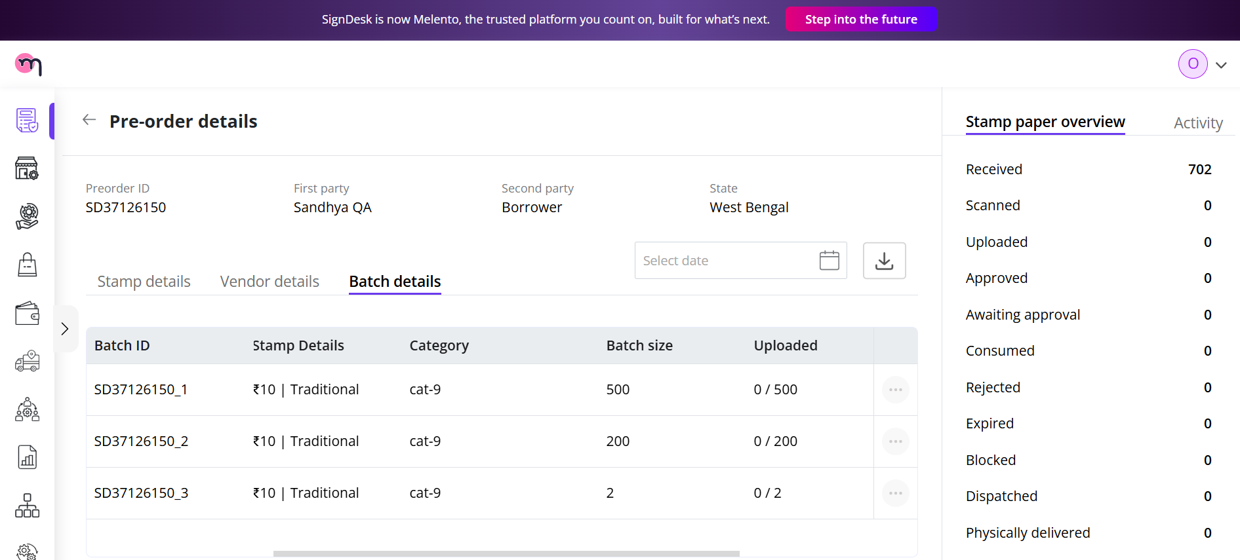

This ensures each batch is accurately logged and traceable throughout the dispatch workflow.

## **Uploading Stamp Papers via SignDesk Upload**

After creating batches, the procured stamp papers must be uploaded using the internal tool **SignDesk Upload**. This ensures that all stamps are available in the system for dispatch.

**Steps to Upload Stamp Papers:**

1. Open the **SignDesk Upload** tool.
2. Fill in the required details:
   * **Procurement ID (Pre-Order ID)**: The ID of the pre-order associated with the stamps.
   * **Vendor**: Select the vendor supplying the stamps.
   * **Pre-Order Batch Number:** Indicate the batch number being uploaded.
     + Upload the folder containing the stamp papers for that batch.

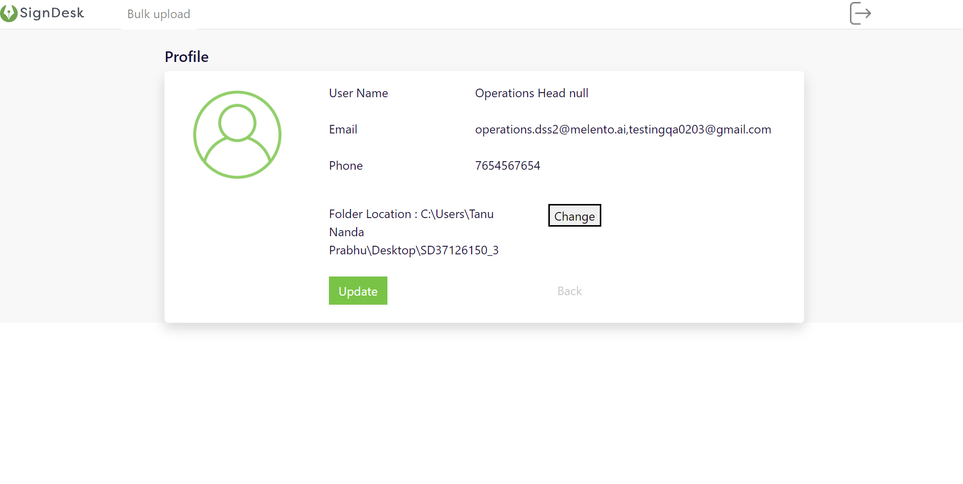

* + - **Important:** The folder name must exactly match the batch number.
      * *Example:* For Batch 1 (500 stamps) and Batch 2 (2 stamps), upload the stamps in folders named “Batch 1” and “Batch 2” respectively.

1. Provide additional details:
   * **File Format**: Ensure the uploaded files match the required format.
   * **Stamp Date**: Enter the date of the stamp papers.
   * **Stamp Type**: Specify the type of stamp (Traditional or On the Fly).

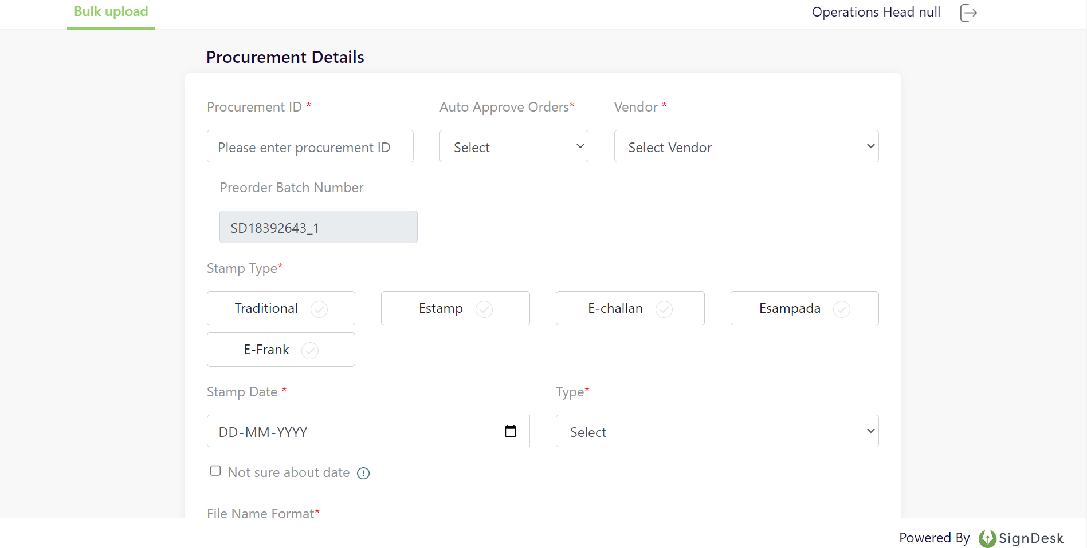

1. Verify all information is correct, then click **Submit**.

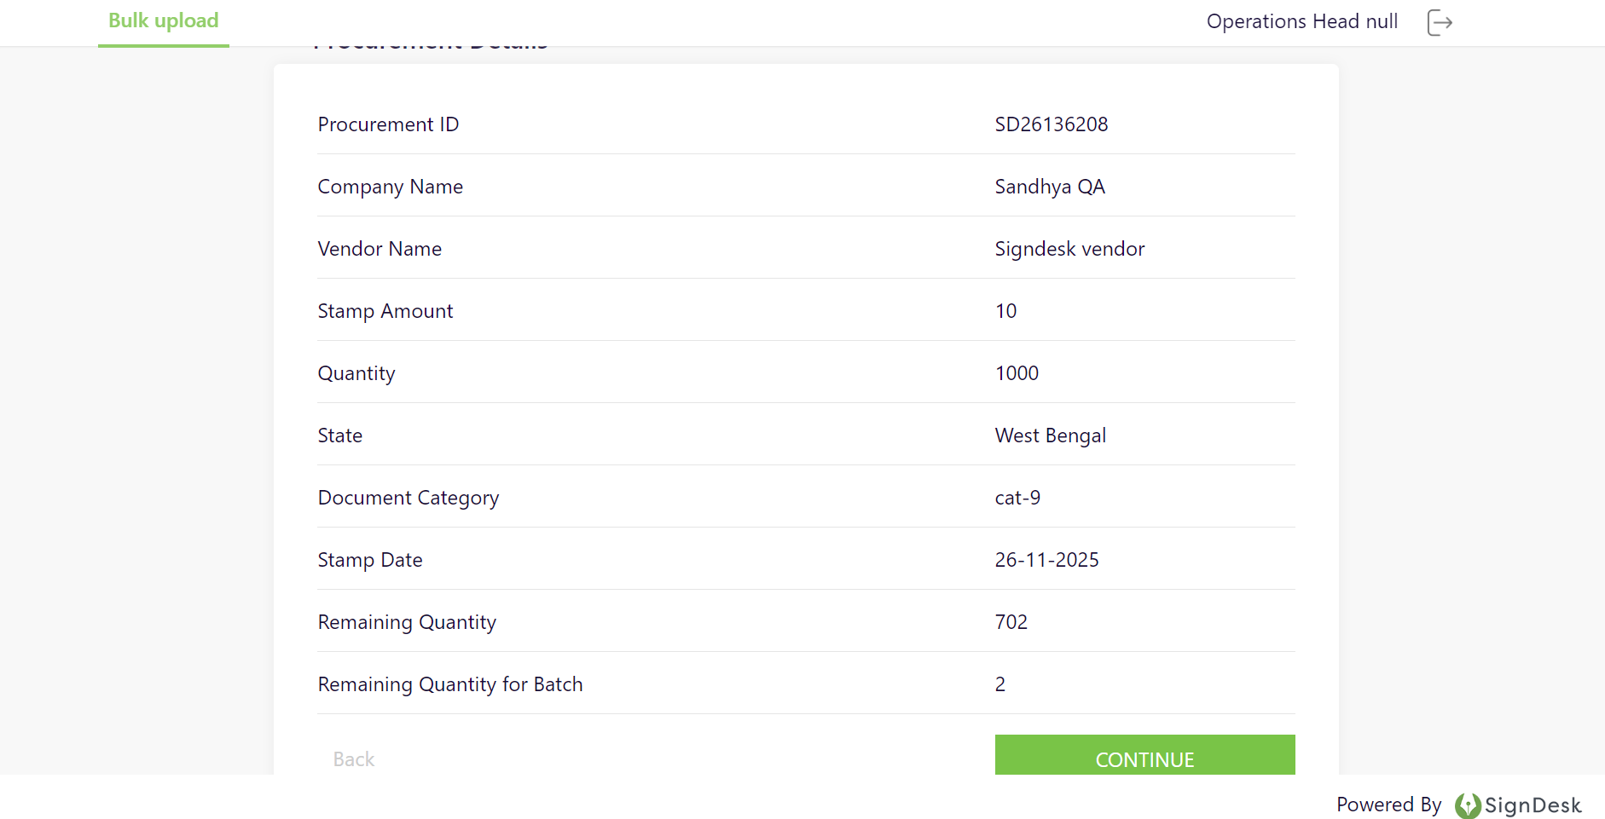

**Outcome:**

* Upon successful upload, returning to the **Operations Portal Dashboard** will show the status of the batch updated to **Uploaded**.

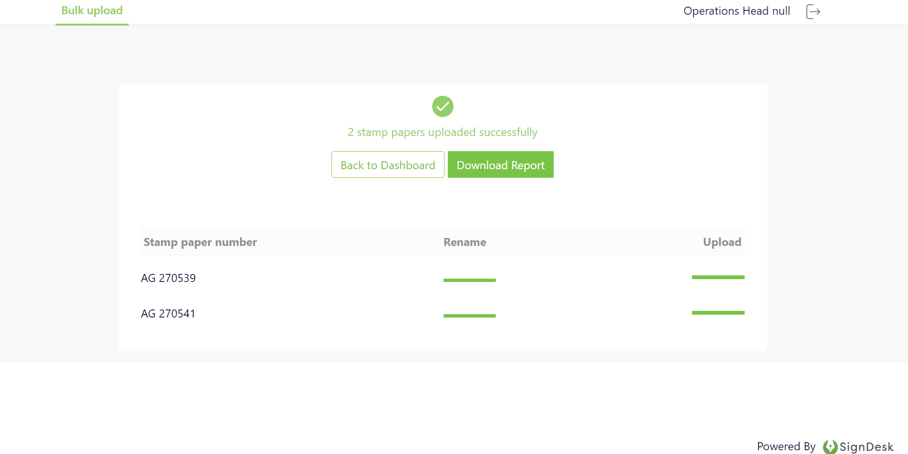

* The uploaded stamps are now ready for dispatch preparation and further tracking in the system.

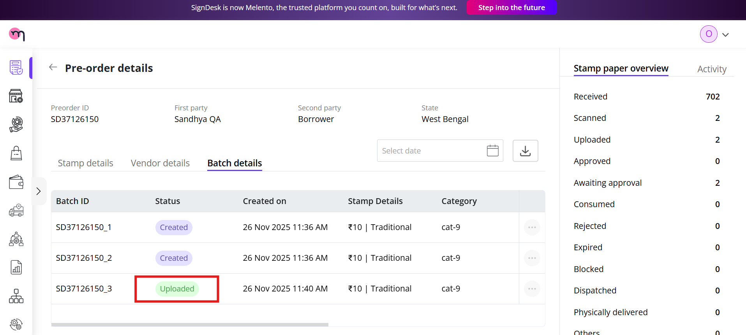

## **Client**

### **Consuming Stamp Papers**

Once the stamp papers are uploaded by Operations, the client can consume them for stamping documents. This involves creating a new workflow and attaching the relevant stamp papers to the document.

**Methods to Consume Stamp Papers:**

Clients can consume stamp papers using **two methods,** depending on their preference and integration setup:

1. **Web Portal**
   * The client logs into the SignDesk Dashboard.
   * Creates a new workflow and uploads the document to be stamped.
   * Selects the required stamp papers (from the uploaded batches).
   * Submits the workflow to initiate stamping.
2. **API Integration**
   * Clients can consume stamp papers programmatically using the SignDesk API.
   * The document to be stamped is attached via an API request.
   * The system allocates the appropriate stamp papers from the uploaded batches.
   * The API response confirms successful consumption and links the stamps to the document.

**Steps for Web Portal Consumption:**

1. **Log in** to the SignDesk Dashboard with client credentials.
2. Navigate to the workflow module and click **Create New Workflow**.

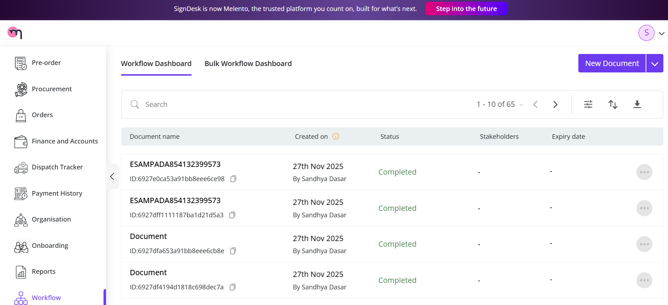

1. Upload the **document to be stamped**.

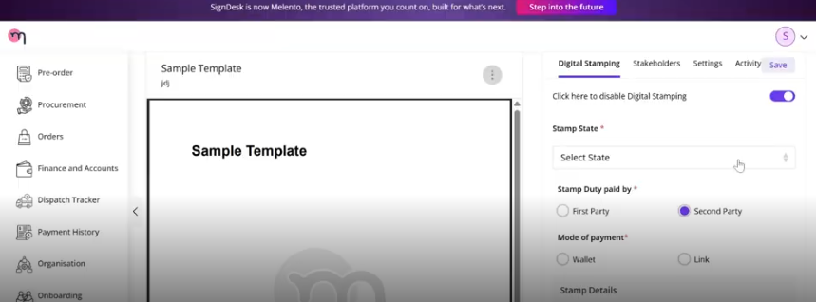

1. Submit the workflow to initiate stamping.

**Outcome:**

* The stamp papers are **consumed** and linked to the uploaded document.

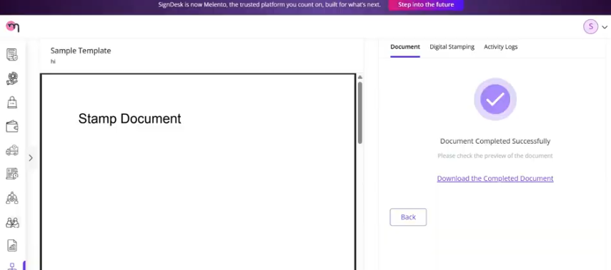

* The Operations dashboard reflects the usage for transparency and auditing.

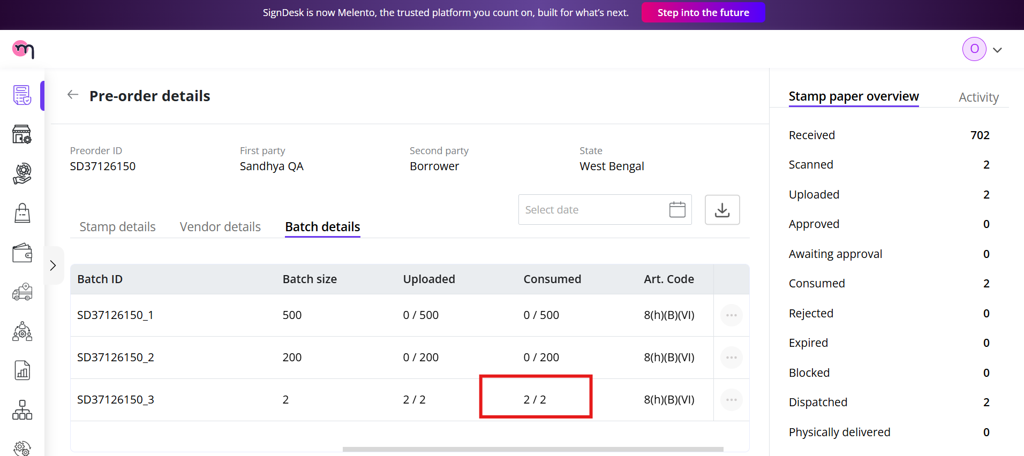

The status will change from **Uploaded** to **Awaiting Dispatch,** as shown below

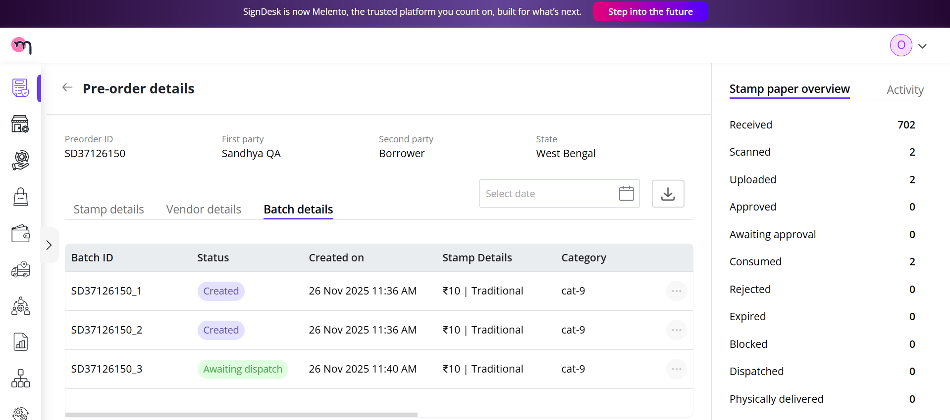

The recent batch can then be found in the Awaiting Dispatch tab.

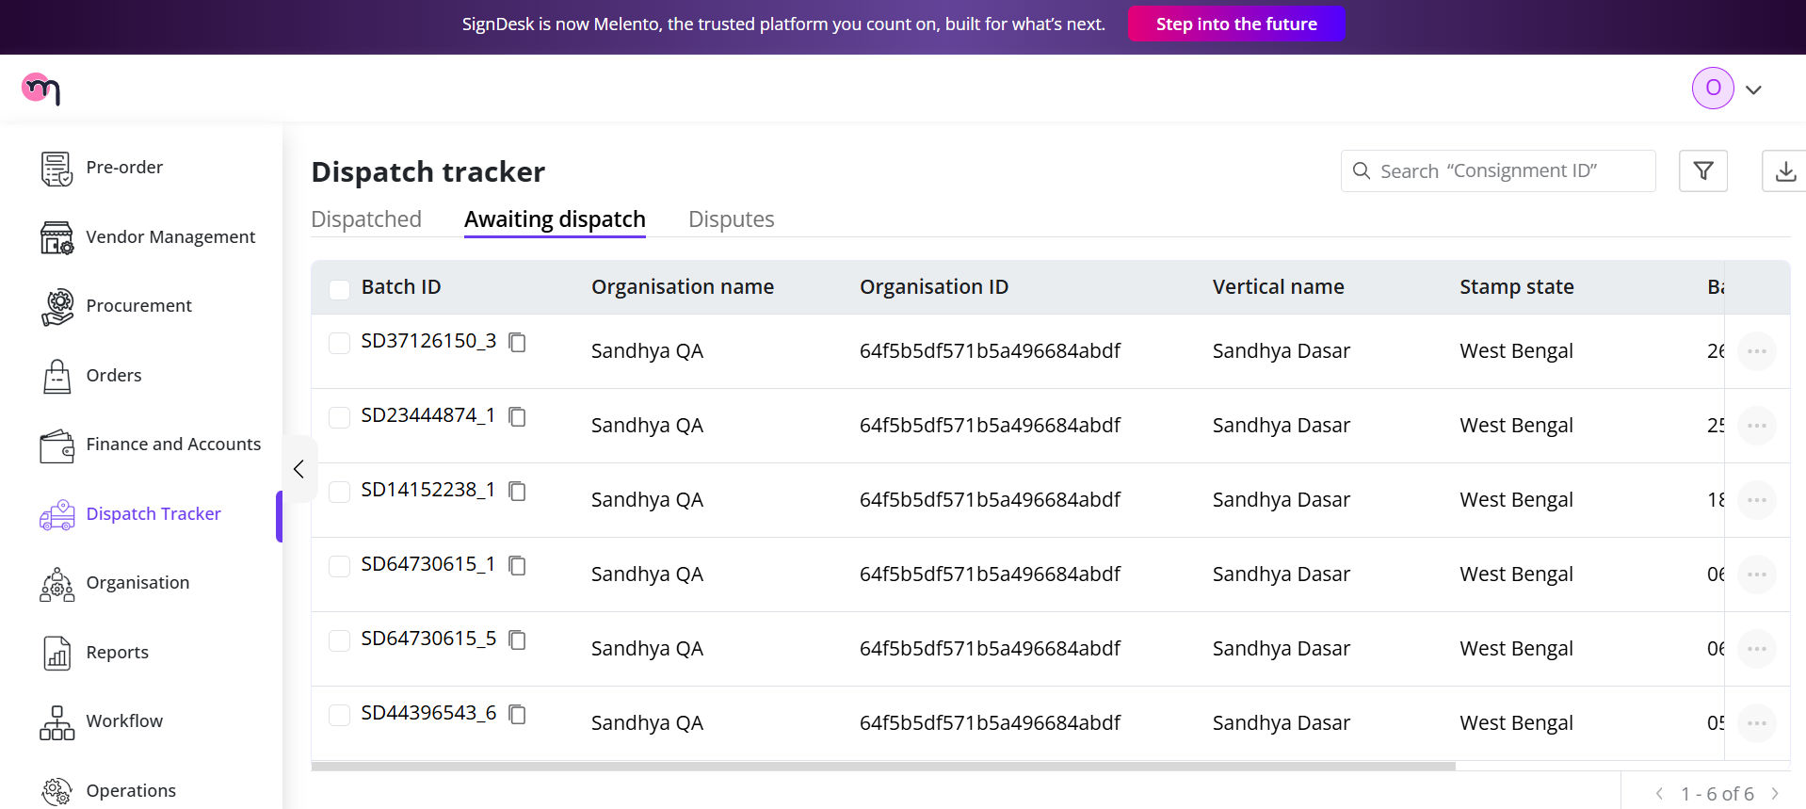

You can view the details by clicking on the specific batch that you want to view.

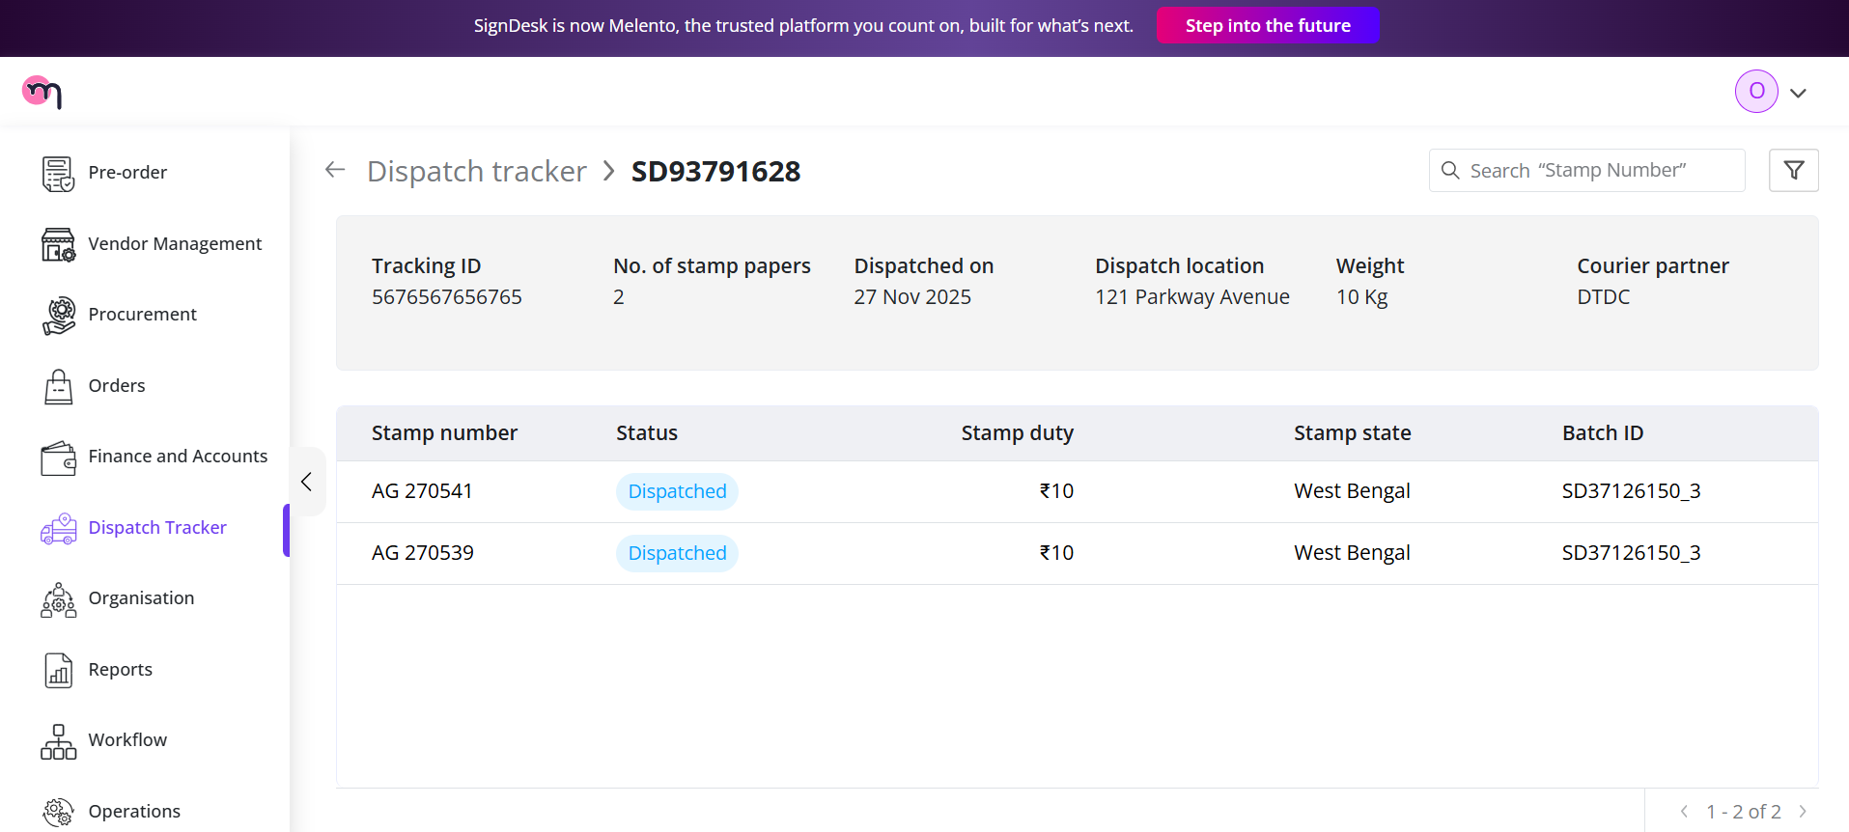

To deliver the batches, you can revisit the Marking a Consignment as Delivered; the process remains the same!

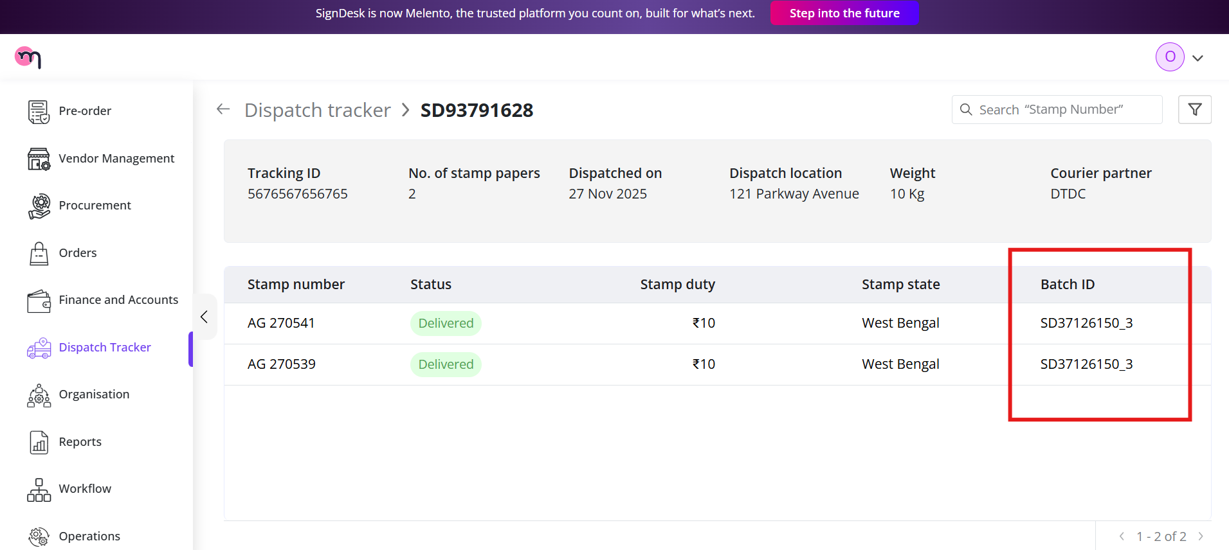

As shown in the above screenshot, the Batch ID will be displayed.

# **Conclusion**

In the **On the Fly** workflow, stamp papers are uploaded in bulk via CSV, and therefore, **Batch IDs are not displayed** in the dashboard.  
In contrast, the **Traditional** workflow involves vendor procurement and structured batch creation, so **Batch IDs are clearly displayed** and tracked throughout the process.

This distinction ensures that each workflow maintains the appropriate level of traceability based on how the stamps are sourced and managed.

|  |  |
| --- | --- |
| **On the Fly** | **Traditional** |

# **Appendices**

## **Glossary**

| **Term** | **Definition** |
| --- | --- |
| Consignment ID | A unique identifier automatically assigned to each dispatch entry. Used to track consignments across statuses (Awaiting Dispatch, Dispatched, Delivered, Dispute Raised). |
| Batch ID | An identifier for a group of stamp papers procured and uploaded together.  - Present in Traditional workflow (vendor procurement and batch creation).  - Not applicable in the On the Fly workflow. |
| Pre‑Order | A projection request created in the Traditional workflow before procurement. Requires Finance and Management approval before Operations can assign a vendor. |
| CSV Upload | Bulk upload method for On the Fly workflow. Must include mandatory fields:  - Stamping Number (unique identifier)  - Stamp State (e.g., Karnataka, Maharashtra)  - Stamp Amount (denomination)  CSV files must avoid duplicates, redundancies, and invalid entries. |
| Vendor Assignment | The process where Operations assigns a vendor to fulfill a Traditional pre‑order. Vendors then update procurement details, create batches, and upload stamp papers. |
| Dispatched Tab | Dashboard view showing consignments already sent through courier. |
| Awaiting Dispatch Tab | Dashboard view showing consignments uploaded but not yet dispatched. |
| Disputes Tab | Dashboard view showing consignments flagged for discrepancies. |
| Delivered Date | Field used when marking a consignment as delivered, confirming receipt by the client. |
| Upload Receipt | Proof of delivery is uploaded by Operations when marking a consignment as delivered. |

## **Troubleshooting**

| **Issue** | **Example / Cause** | **Fix** |
| --- | --- | --- |
| CSV Upload: Missing Mandatory Fields | Example: Stamping Number, State, or Amount not provided. | Correct the CSV and re‑upload with all required fields. |
| CSV Upload: Invalid Data Formats | Example: Incorrect state codes, non‑numeric stamp amounts, and empty rows. | Ensure data matches required formats and remove empty rows. |
| CSV Upload: Duplicate Entries | Example: Same Stamping Number appears multiple times in the CSV. | Remove duplicates before re‑uploading. |
| CSV Upload: Redundant or Invalid Entries | Example: Repeated or mismatched data across rows. | Validate consistency before upload. |
| Pre‑Order: Rejected by Finance Team | Cause: Budget constraints, incomplete details, or compliance issues. | Review rejection comments, revise details, and resubmit. |
| Pre‑Order: Disapproved by Management Team | Cause: Strategic or compliance concerns. | Revise the request and resubmit for approval. |
| Pre‑Order: Vendor Assignment Errors | Cause: Incorrect vendor selection or missing procurement details. | Reassign vendor or update procurement form. |
| Dispatch, Consignment Not Updating to Delivered | Cause: Delivered Date or Receipt not uploaded. | Ensure both fields are completed before submission. |
| Dispatch, Dispute Raised Automatically | Cause: CSV mismatches, duplicate stamping numbers, or invalid entries. | Correct data and re‑upload; Operations team reviews disputes. |